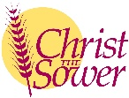
Creating space in schools where children can pause to reflect or pray.

Christian Distinctiveness, CARE and opportunities for spiritual development:
We have a range of opportunities for pupils to develop their spirituality and to live though CARE to build their personal development and to enrich their learning.
(School Development Plan 2024-2025)

Spiritual Development
Children are naturally curious about life. They have lots of questions: some to do with their experience and some to do with their sense of wonder at the universe that we live in. A prayer and reflection space helps them to develop their own sense of identity, self-worth, personal insight, meaning and purpose. This enables children of all faiths and none, to explore these life questions, spirituality and faith in a safe, creative and interactive way.

At CtS each class will have a clearly identifiable area of the classroom as a prayer and reflection space based around the class value. This space is rooted in broadly Christian traditions of prayer, whilst allowing children to respond individually and draw their own conclusions. Each class will have a prayer box containing items that may help children to reflect.
Contents
- Prayer and reflection book – for children to write/draw their own prayers/reflections/responses
- Bubbles, candle, mirror, heart shaped post its, pebbles, picture frame,
glass beads, pipe cleaners, teaspoon tsp (thank you, sorry, please prayers)

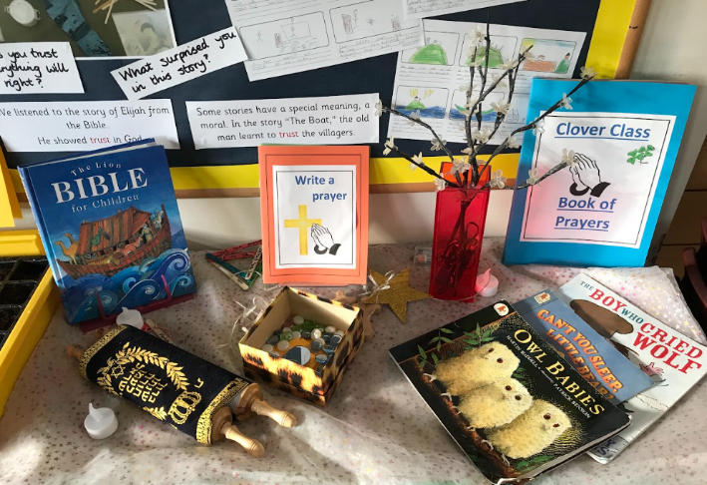
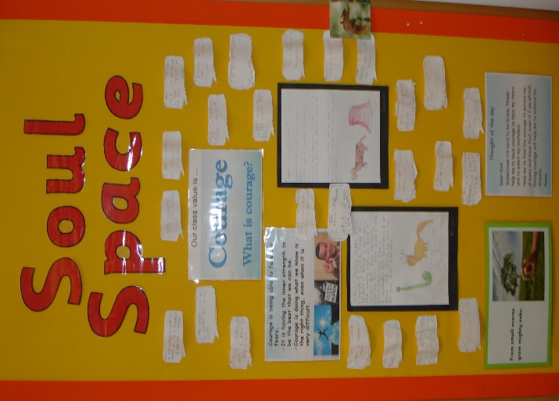

Regularly, teachers will take some time to discuss a different theme with their class. This may be our school story – the parable of the Sower, the class value, assembly theme, religious festival or national event (e.g. harvest/creation care, Remembrance, Festivals of light, Advent, Christmas).
It may include a song – pop song, school songs and faith songs that build on the class value or a time of quiet. It will allow time for children to respond and share from their own faith perspectives.

Teachers will also use this opportunity during the course of the year to teach/reflect with children our core prayers and blessings.

Core prayers and blessings
The Lord’s Prayer  Our Father in heaven,  Hallowed be your name  Your kingdom come,  Your will be done  On earth as in heaven.  Give us today our daily bread  And forgive our sins,  As we forgive those who sin against us.  And lead us not into temptation  But deliver us from evil,  For the kingdom, the power and the glory are yours,  Now and forever. Amen | Blessings  May the grace of our Lord Jesus Christ  and the love of God  and the fellowship of the Holy Spirit  be with you all. Amen  May the Lord bless you and keep you,  May He make his face shine upon you,  May the Lord turn his face to you  And grant you peace. Amen
School Prayer

As we gather together again
At the start of the day.
Lord, we ask that you help us
To live lives that please you,
In forgiveness, respect with reverence,
With compassion and strong perseverance,
Showing courage and thankfulness.
Serving one another as faithful friends
With loving care
Amen

Ideas and activities for Class reflection/prayer From Prayer spaces in Schools
Peace dove |  | Refugees | Bubble Prayers
Need:  Camouflage net, dove templates  Think about or pray for situations of conflict or war and those people working to bring peace. Drape a piece of camouflage net over furniture keeping it low enough for children to be able to reach it. Ask children where there is fighting. They may have seen pictures in the media. Cut out a dove shape and on it write a short prayer for the people who are trying to bring peace into that situation. Tuck the prayer dove into the camouflage net. The intention is that the camouflage net will become white with the cloud of doves of peace. |  | Need:  A6 size rectangles of card  When there is fighting people often have to leave their homes. They do not have anywhere to go and so may have to live in a refugee camp in another country. Sometimes they live in tents in huge tent cities. Can you imagine living in a tent all the time, even when it snows?  Take one of the pieces of card and fold it in half to make a simple tent. Inside write your prayer for the people who have fled their homes and are now refugees on the tent.  Place the tent with the others to make a model of a tent city as you pray your prayer. | Need:  Bubbles  We all worry about things. Maybe things at home, or things at school? Maybe things about ourselves, or about those we love? Are you worried about something? If you want to, you can use the bubbles to ‘blow your worries away’ as you blow bubbles into the air. You might like to ask God to help you, and to give you courage to talk with someone too. When you feel worried, it’s good to talk about your feelings with a trusted adult, a parent or a teacher. You may want to include these words from 1 Peter 5v7; “Cast all your worries onto God because he cares for you.
Opportunity Keys |  | Different and special | Autumn Leaves
Need:  Bowl of keys, door outline  What opportunities and challenges are you facing? Maybe you’ve got an opportunity to do something new? Maybe a particular friendship is challenging? It could be at home/school, or maybe it’s personal? Imagine that these things are like a door into something new. What key do you need to unlock the door? If you want to, place one of the keys in the bowl as a symbol of choosing to unlock your opportunity/challenge. If you want to, you can quietly ask God to give you courage. |  | Need:  Cut out of a person, different coloured paper cut in to squares  We all have different colour skin, backgrounds and cultures. Take a piece of material, paper, card, etc and write your name on it. Stick it on the person-shape in front of you. As you do this, think about how each piece of material is different but special and they all work together to make a beautiful mosaic. You might want to say a prayer or a wish, and to quietly thank God that we are all different and special. We all have something to contribute. | Need:  Leaves or template of leaves, large outline of a tree  As the seasons change, the trees change. Leaves change colour and they eventually fall to the ground. We go through seasons in our lives too. Some things come to an end, and others begin. The change can be difficult. What’s changing for you? At school? With your friendships? In your family? Is there something that you want to change? If you want to, you can write or draw a thought or a prayer about what’s changing onto a leaf and add it to the tree
Thankful Playdough |  | Reconciliation zips | Pipe Cleaner People
Need:  Playdough  Think about all the good things in your life. Think of someone or something that you are really grateful for. Use some of the playdough to make a model of the thing you have thought of. If you want to, while you are making your model use the time to say thank you to God. |  | Need:  Zips  When people argue and fight, they get separated from each other. They’re not together anymore. Have you argued with someone recently? Do you know  people who don’t get on well together? Zips are clever. Zips bring two sides together. Reconciliation means bringing two sides together.  Pick up a zip and think about the people that you want to bring back together. If you want to, you can say a quiet prayer for the people you’re thinking of as you do up the zip. This is a reconciliation prayer | Need:  Pipecleaners  Think about someone you know, someone in your family or a close friend.  Maybe you know someone who needs help at the moment, or who is unwell?  As you think about what makes this person special to you, make a model of them out of pipe cleaners and if you want to, say a silent prayer for them.
Advent Stars of wonder |  | Advent Prayer chains | Christmas journey
 | Need:  star templates, different materials, tree  Create own stars from different materials  Make these stars of wonder by adding on your own questions that you are wondering about. ..questions that seem to have no answer on earth. Hang these as messages to God from a tree. | Need:  strips of red and green paper, tape  Take a moment to consider the names of people, places, or causes you would like to lift up in prayer. As these names come to your mind, write them down on a strip of green or red paper. Then, use the tape to connect your strips as loops to the paper chain as a way of connecting your prayers with the prayers of others. | Need: footprints template, fairy lights (optional) – place along a pathway  In the Christmas story, Mary and Joseph travel at least 110km from Nazareth to Bethlehem. On a donkey! Life is a bit like a long journey, and we have lots of experiences along the way. This year is nearly over. What are the big things that you remember from this year? What happened? What was good about it? Was anything bad, or sad? If you want to, you can write or draw about an important moment onto one of the footprints... and then leave it behind as you begin your journey into the New Year
Further ideas: Prayer Spaces In Schools (free sign up to access resources)
Collective worship - Diocese of Guildford (cofeguildford.org.uk)

