Choral Singing at Christ Church Cathedral, Oxford
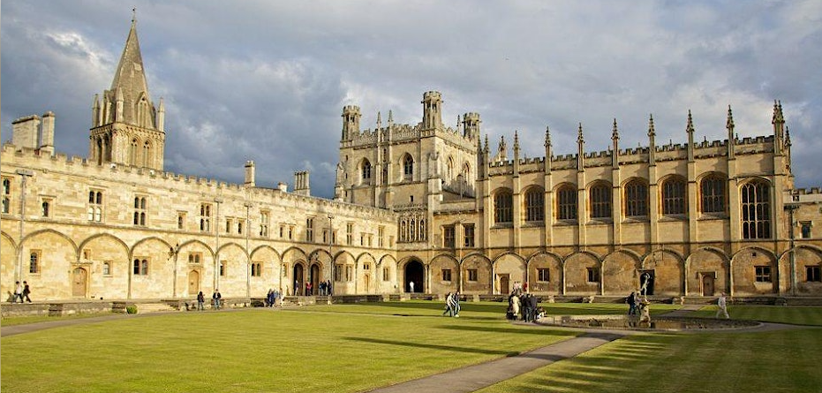

Dear Parents and Carers
We have been given the fantastic opportunity to take a choir of 40 pupils to Christ Church Cathedral in Oxford to perform at the annual ODBE Annual Service for Headteachers and Governors 2023. This is a wonderful privilege, to sing in such a prestigious cathedral alongside 2 other schools (Lewknor CE Primary school and Sunningwell Primary School)
This whole day trip will take place on 7th December 2023, we will take a coach to the church and spend the morning in rehearsals. Children will get the chance to tour the Cathedral and have playtime in the grounds. The cost of the day will be £7 (to cover the cost of the coach)
Our children have also been asked to write and perform the prayers on the day, so we will be selecting some of the pupils who are coming to undertake this task too.
Key Stage 2 pupils of all faiths and none are welcome to apply. We would love to take a full choir of 40 pupils and really showcase how fantastic our children are at worshipful singing.
Once we have selected the children, Miss Barr and Miss Nugent will be holding lunchtime rehearsals to prepare for the day, so children should be fully prepared to attend these sessions please.

Places will be allocated on a first come, first served basis, we ask that you book your space using ________________________________

