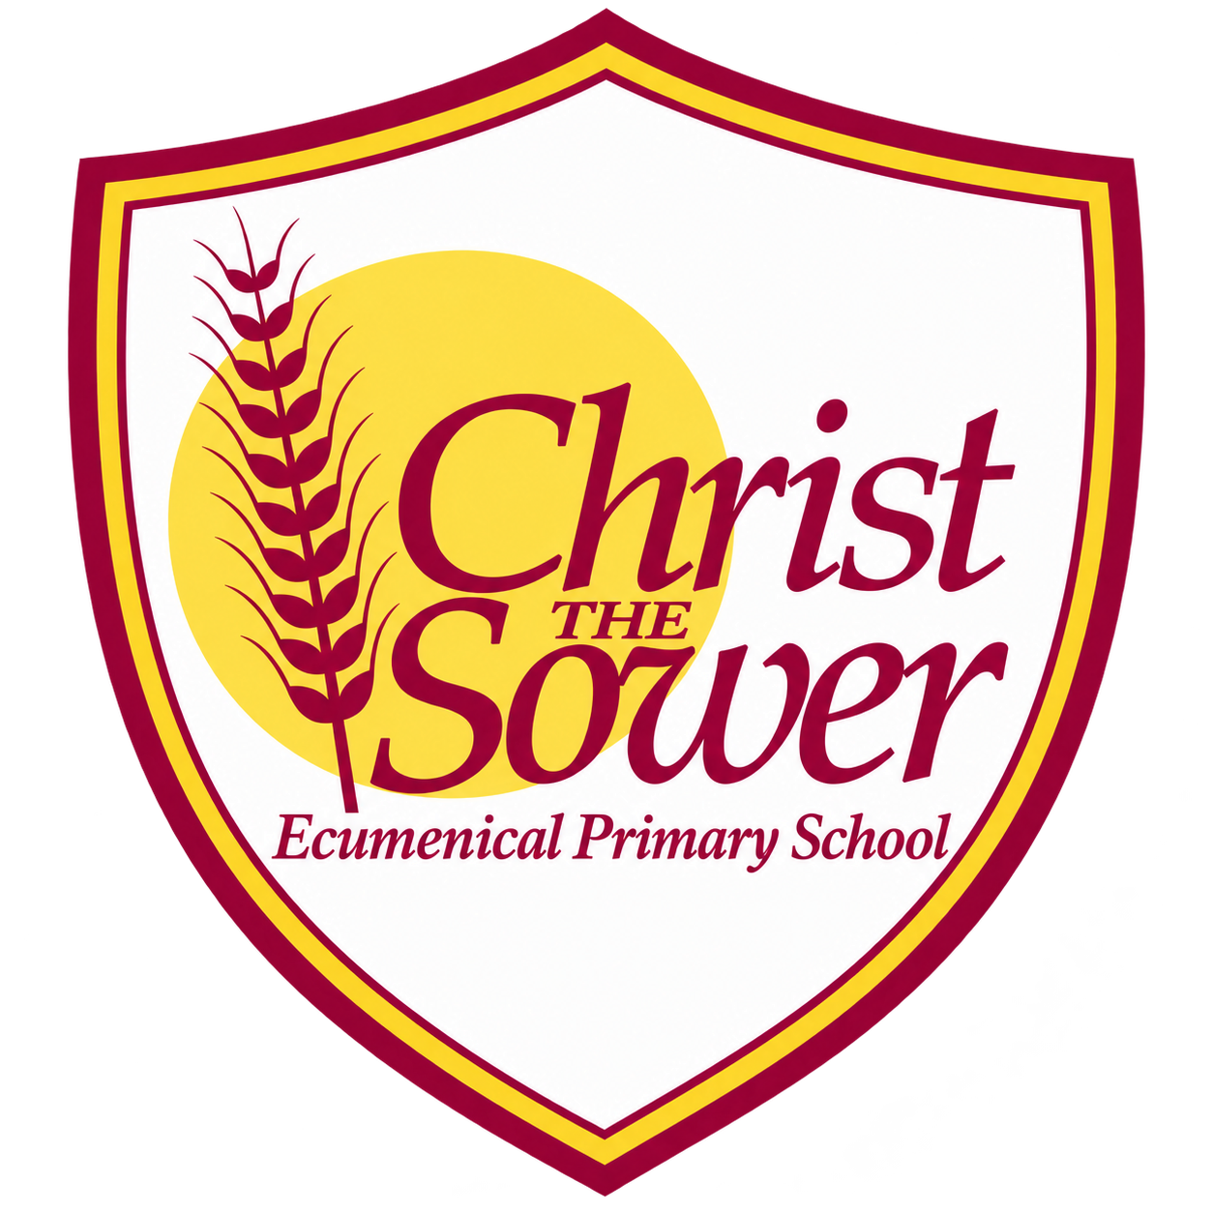 | YEAR 5 • HISTORY • AUTUMN 1  Kingdom of Benin | KNOWLEDGE  ORGANISER

BIG QUESTION | How did the Kingdom of Benin become an empire?

 | → |  | →
  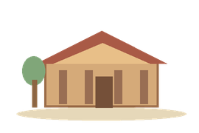 | EARLY KINGDOM  c. AD 1200s–1300s  Edo rulers and Benin City
   | GOLDEN AGE  1400s–1600s  Trade and royal art flourish
  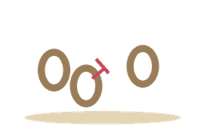 | BRITISH INVASION  1897  Benin City is attacked

  WHAT SHOULD I KNOW?
  Where was the Kingdom of Benin? It developed in West Africa, in what is now southern Nigeria. It was not the same place as the modern country called Benin.
  Who ruled Benin? Its rulers were called Obas. Benin City was the royal centre, and the Oba held great power.
  How did Benin become powerful? Trade routes linked the West African coast with inland areas. Rulers expanded their influence and wealth.
  What was traded? People exchanged goods such as cloth, ivory and metals. The trade also included enslaved people.
  What was Benin’s Golden Age? A period of growing power and rich artistic achievement. Skilled craftspeople made brass plaques and sculptures for the royal court.
  Why did Benin lose power? Conflicts over leadership and changes in trade weakened it. Britain later sought control over Benin’s land and commerce.
  What happened in 1897? British forces invaded Benin City, removed the Oba from power and took many royal artworks.
  WORDS TO REMEMBER
  Oba a title for the ruler of Benin
  Edo the people and culture of the Benin kingdom
  Kingdom land ruled by a king or queen
  Empire lands controlled by one powerful state
  Trade buying, selling or exchanging goods
  Golden Age a time of great success or achievement
  Artefact an object from the past
  Enslavement forcing people to live without freedom
  Colonialism one country taking control of another place
  HISTORY DETECTIVES
  Brass plaques, sculptures and written accounts tell us about Benin. Ask who created each source and whose view it shows.

POWER & RULE  Obas • royal authority | TRADE & CHANGE  Routes • wealth • enslavement | EVIDENCE & LEGACY  Artwork • different viewpoints

EVIDENCE WE EXPLORE | Brass plaques • Sculptures of Obas • Historical maps and written accounts

