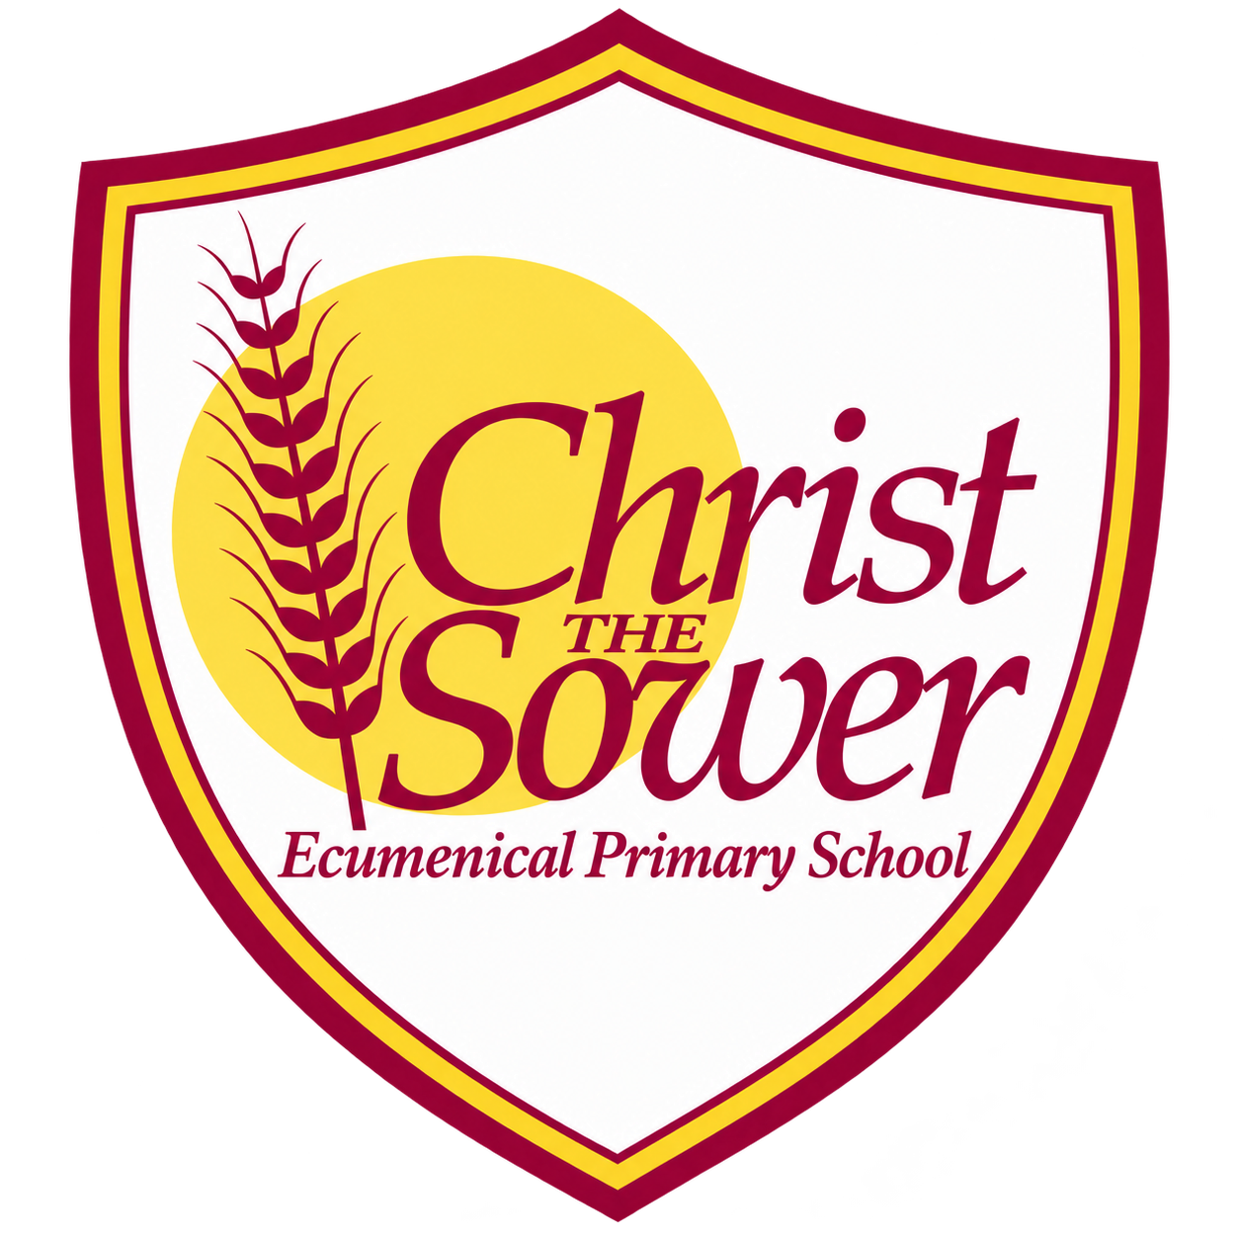 | YEAR 6 • HISTORY • SPRING  The Victorians | KNOWLEDGE  ORGANISER

BIG QUESTION | Was it better to be a Victorian child or a child today?

 | → |  | →
  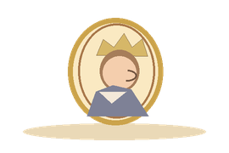 | VICTORIAN ERA BEGINS  1837  Queen Victoria becomes monarch
  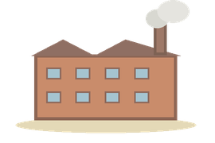 | INDUSTRIAL CHANGE  1800s  Factories and cities expand
  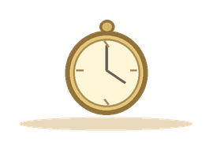 | VICTORIAN ERA ENDS  1901  Queen Victoria dies

  WHAT SHOULD I KNOW?
  When was the Victorian era? It lasted from 1837 to 1901, during Queen Victoria’s reign in Britain.
  What was the Industrial Revolution? A period of rapid change as machines and factories transformed work, transport and towns. It began before Victoria’s reign and continued during it.
  How did towns and jobs change? Many people moved to growing towns and cities for factory work. Industrialisation also increased pollution and overcrowding.
  Was life the same for everyone? No. Wealthier families usually had more comfortable homes and opportunities. Poor families often faced long working hours and difficult conditions.
  What was life like for poorer children? Some worked to support their families. Children living in workhouses faced strict routines and harsh conditions.
  How did society respond to poverty and crime? Workhouses provided harsh poor relief, while policing, prisons and punishments changed during the nineteenth century.
  How do we know about Victorian life? Photographs, records, drawings and written accounts show different experiences. A single source may not tell the whole story.
  WORDS TO REMEMBER
  Victorian era the years of Queen Victoria’s reign, 1837–1901
  Monarch a king or queen
  Industrial Revolution a period when machines and factories changed life
  Social class a group in society linked to wealth or position
  Workhouse a place where some poor people lived and worked for relief
  Poor relief help given to people living in poverty
  Transportation sending convicted people overseas as a punishment
  Primary source evidence created at the time being studied
  Bias a viewpoint that may favour one side
  HISTORY DETECTIVES
  Compare a photograph, a written account and a drawing. Whose experience is shown? Who created the source, and what might it leave out?

CHANGE & CONTINUITY  Factories • towns • transport | SOCIETY & INEQUALITY  Rich and poor • children • work | REFORM & EVIDENCE  Workhouses • policing • sources

EVIDENCE WE EXPLORE | Victorian photographs • Workhouse records • Written accounts • Illustrations
Link back: compare the Industrial Revolution with earlier technological changes; connect Victorian Britain with the British Empire studied in Year 5.

