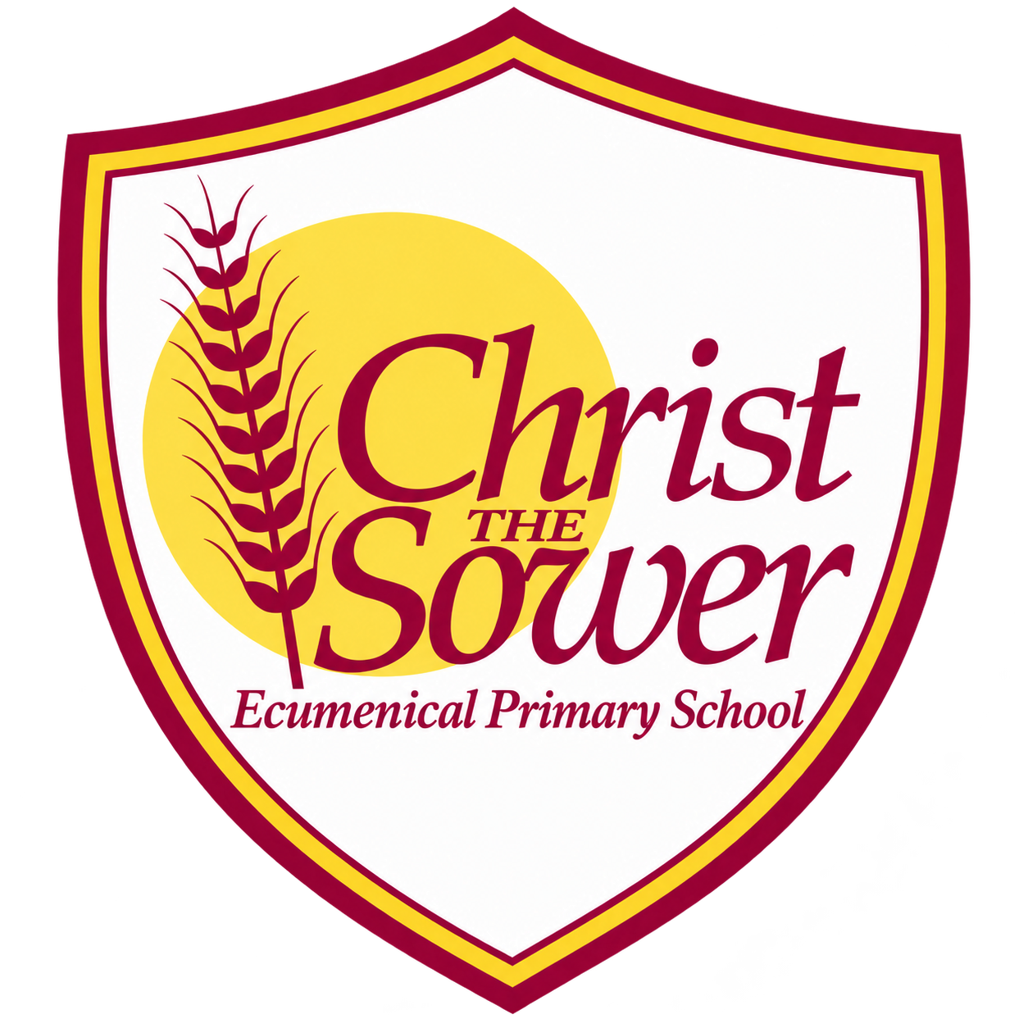 | YEAR 4 • HISTORY • AUTUMN 1  The Romans in Britain | KNOWLEDGE  ORGANISER

BIG QUESTION | What impact did the Roman Empire have on Britain?

 | → |  | →
  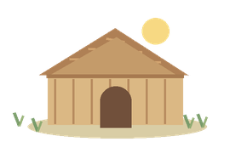 | IRON AGE BRITAIN  Before AD 43  Tribes lived in Britain
  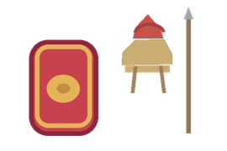 | ROMAN INVASION  AD 43  Claudius sends the army
  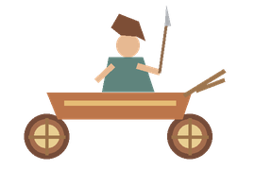 | BOUDICCA’S REVOLT  AD 60/61  Britons resist Roman rule

  WHAT SHOULD I KNOW?
  What was Britain like before the Romans? In Iron Age Britain, people lived in tribal communities with their own leaders.
  What is an empire? An area of land made up of different places ruled by one state or ruler.
  Why did Rome invade Britain? The Romans wanted to expand their empire and gain land, crops and valuable resources.
  How did the Romans conquer Britain? Their well-trained, organised army used strong equipment and battle formations.
  Who was Boudicca? A leader who resisted Roman rule and led a revolt against the Romans.
  How did Roman rule change Britain? Romans built roads and towns, including Londinium (London) and Eboracum (York), and public buildings such as baths.
  What is the Roman legacy? Roads, towns and remains from Roman Britain still influence how we live and help us learn about the past.
  WORDS TO REMEMBER
  Empire lands controlled by one ruler or state
  Invasion entering a place to take control by force
  Conquest taking control of land by force
  Legionary a soldier in the Roman army
  Emperor the ruler of the Roman Empire
  Resistance fighting or standing against control
  Source evidence we can use to learn about the past
  Legacy something left from the past that still matters
  Public baths places where Romans washed and met others
  HISTORY DETECTIVES
  Accounts of Boudicca can differ. Ask who created each source and when.

EMPIRE & CONQUEST  Invasion • army • control | CHANGE IN BRITAIN  Roads • towns • public baths | RESISTANCE & LEGACY  Boudicca • different views • today

EVIDENCE WE EXPLORE | Roman accounts of Boudicca • Maps of Roman roads and towns • Soldier equipment

