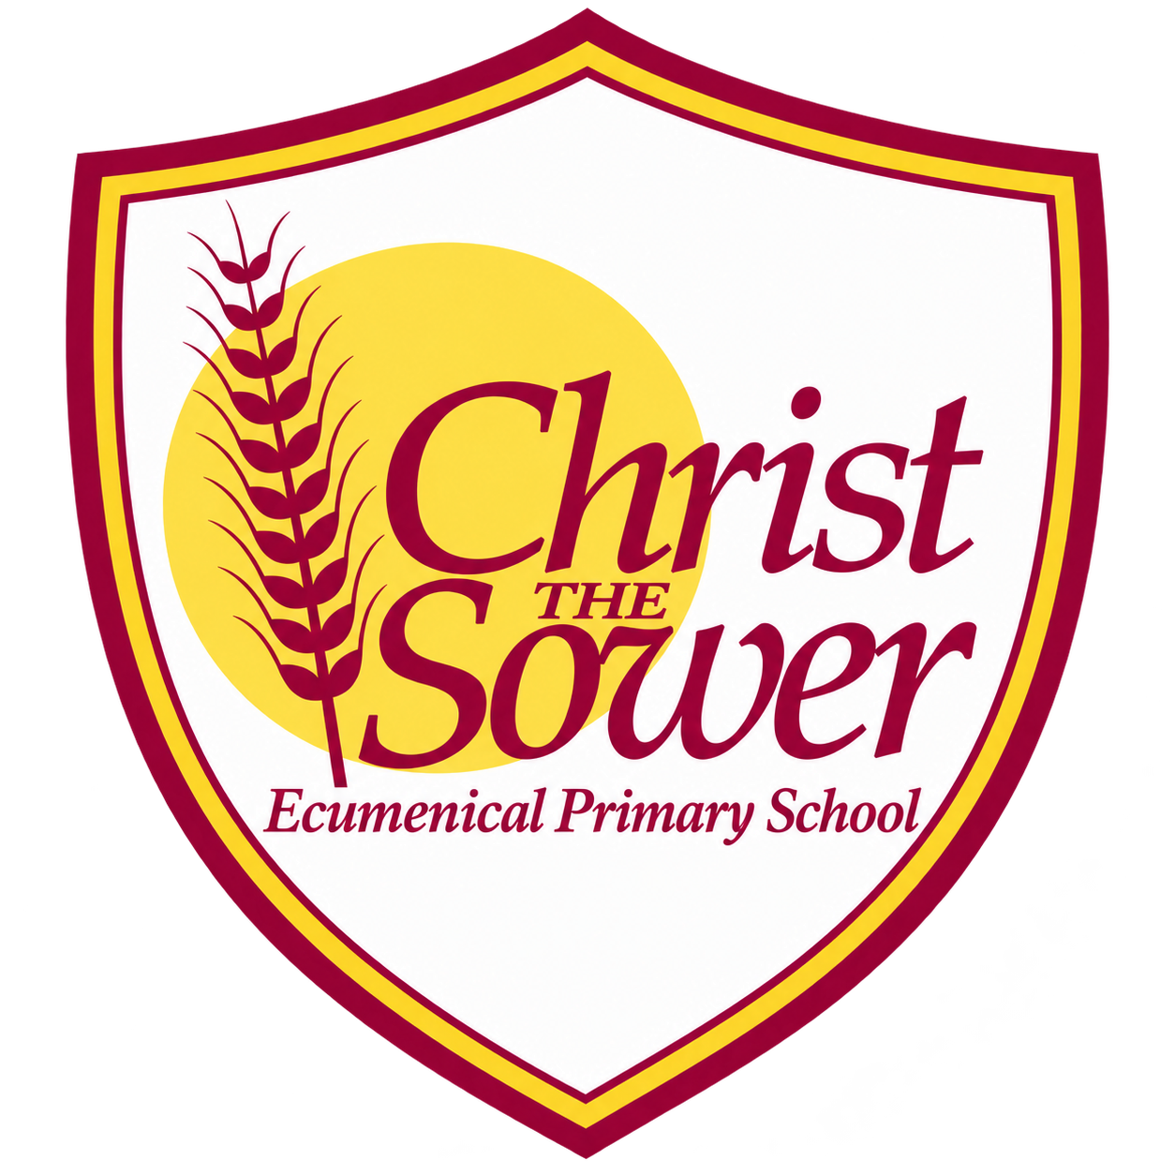 | YEAR 4 • HISTORY • SUMMER 2  Anglo-Saxons and Vikings | KNOWLEDGE  ORGANISER

BIG QUESTION | What impact did invaders and settlers have on life in Britain?

 | → |  | →
  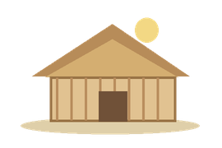 | ANGLO-SAXON SETTLEMENT  From the 5th century  Angles, Saxons and Jutes settle
  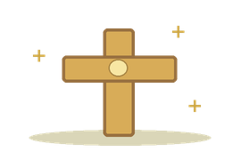 | CHRISTIANITY SPREADS  From AD 597  New beliefs spread widely
  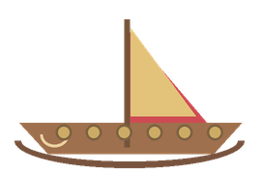 | VIKING RAIDS BEGIN  AD 793  Lindisfarne is attacked

  WHAT SHOULD I KNOW?
  Why did Anglo-Saxons come to Britain? After Roman rule ended, groups including the Angles, Saxons and Jutes migrated from northern Europe to settle in Britain.
  How was Anglo-Saxon Britain ruled? It was divided into kingdoms, including Wessex, Mercia and Northumbria, with different kings.
  How did Anglo-Saxons change Britain? They established settlements and influenced the English language. Some modern place names still show where they lived.
  How did beliefs change? Many early Anglo-Saxons followed pagan beliefs. Christianity spread among Anglo-Saxon communities, especially from the late 500s.
  Who was Alfred the Great? A king of Wessex who fought Viking armies and worked to defend his kingdom.
  Who were the Vikings? People from Scandinavia who raided, traded and settled in Britain. Parts of northern and eastern England came under Viking control, called the Danelaw.
  What did the Vikings leave behind? They influenced place names, language and the way some areas were ruled.
  WORDS TO REMEMBER
  Anglo-Saxons groups who migrated to Britain from northern Europe
  Settlement a place where people build homes and live
  Kingdom land ruled by a king or queen
  Pagan following beliefs involving several gods or spirits
  Missionary someone who spreads a religion
  Vikings people from Scandinavia who travelled, traded and raided
  Danelaw part of England once under Viking control
  Legacy something from the past that still affects us
  HISTORY DETECTIVES
  Place names, coins and written accounts help us investigate the past. Different accounts may give different views.

INVASION & SETTLEMENT  Migration • new communities | KINGDOMS & BELIEFS  Rulers • Christianity spreads | CHANGE & LEGACY  Viking influence • place names

EVIDENCE WE EXPLORE | Coins and images of Alfred • Historical accounts • Place-name maps

