 | YEAR 3 • HISTORY • AUTUMN 1  The Stone Age to the Iron Age | KNOWLEDGE  ORGANISER

BIG QUESTION | How did life in Britain change from the Stone Age to the Iron Age?

 | → |  | →
  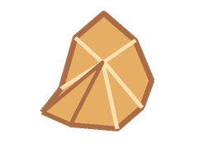 | STONE AGE  c. 800,000–2,500 BC  Stone tools • farming begins
  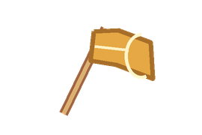 | BRONZE AGE  c. 2,500–800 BC  Bronze tools and objects
   | IRON AGE  c. 800 BC–AD 43  Iron tools • roundhouses

  WHAT SHOULD I KNOW?
  What was the Stone Age? A very long period of prehistory, divided into the Palaeolithic, Mesolithic and Neolithic.
  How did people survive? Early people hunted animals, gathered plants and made tools from stone and other natural materials.
  What changed in the Stone Age? Tools improved. Over time, people began farming, making pottery and living in permanent settlements.
  How do we know about Stone Age life? Archaeologists study footprints, artefacts, human remains and places such as Skara Brae.
  What changed in the Bronze Age? People began making tools and other objects from bronze, changing how they lived and worked.
  What was Iron Age life like? Many people lived in tribal communities and roundhouses. They farmed and made strong iron tools and weapons.
  WORDS TO REMEMBER
  Prehistory time before written records
  Archaeologist someone who studies the past through physical evidence
  Artefact an object made or used by people long ago
  Hunter-gatherer someone who hunts and collects wild food
  Nomad someone who moves from place to place
  Settlement a place where people live together
  Smelting heating ore to extract metal
  Chronology putting events in time order
  HISTORY DETECTIVES
  We ask questions, look at evidence and explain what changed or stayed the same.

FOOD  Hunting and gathering → farming | HOMES  Moving about → permanent settlements | TOOLS  Stone → bronze → iron

EVIDENCE WE EXPLORE | Happisburgh footprints • Cheddar Man • Skara Brae • Stone Age tools

