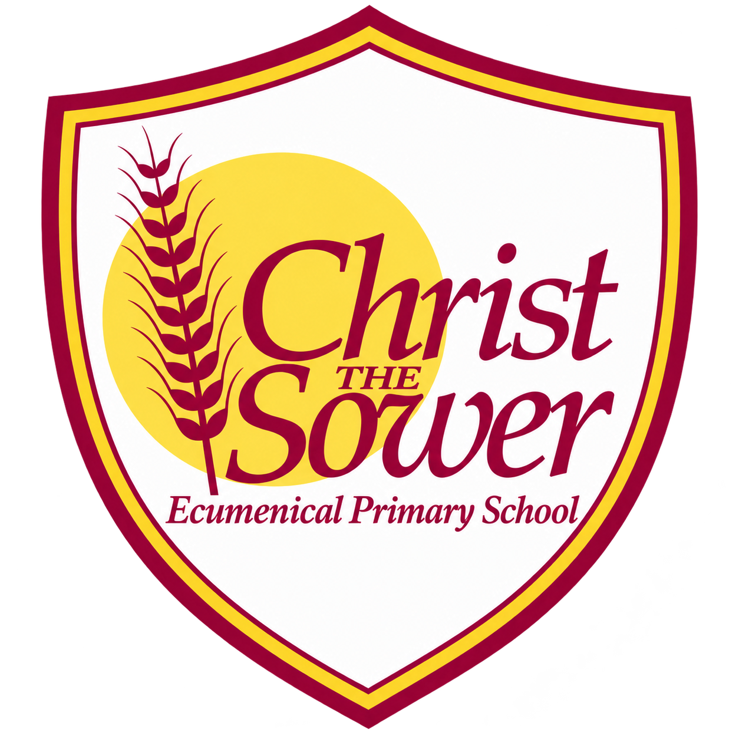 | YEAR 3 • HISTORY • SPRING 2  Ancient Greece | KNOWLEDGE  ORGANISER

BIG QUESTION | How did the Ancient Greeks change the world?

 | → |  | →
  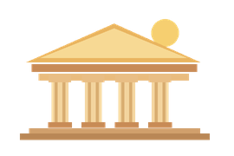 | GREEK CITY-STATES  from c. 800 BC  Athens, Sparta and others
  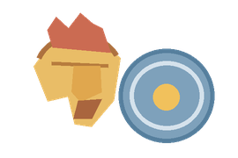 | ALEXANDER THE GREAT  336–323 BC  His empire expands
  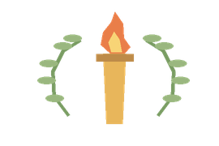 | GREEK LEGACIES  Today  Ideas still shape our lives

  WHAT SHOULD I KNOW?
  Who were the Ancient Greeks? People who lived in a civilisation made up of separate city-states, including Athens and Sparta.
  What was life like for children? Children played games, helped at home and had different experiences depending on their family and city-state.
  How were Athens and Sparta different? Athens valued public life and education, while Sparta was known for its army and military training.
  What did the Ancient Greeks believe? They worshipped many gods and goddesses, whom they believed controlled different parts of life.
  Who was Alexander the Great? A ruler who conquered lands and built a large empire towards the end of the Ancient Greek period.
  What does legacy mean? Something from the past that continues to influence people in the present.
  What Greek ideas influence us today? Democracy, the Olympic Games and theatre are important examples of the Ancient Greek legacy.
  WORDS TO REMEMBER
  Civilisation a society with shared ways of life and culture
  City-state a city with its own government and surrounding land
  Citizen a recognised member of a city or state
  Democracy a system in which citizens take part in decisions
  Mythology traditional stories about gods and heroes
  Empire lands ruled by one person or government
  Legacy something from the past that still matters today
  Olympics a festival of sporting competitions
  Perspective someone’s point of view about events
  HISTORY DETECTIVES
  We study pottery, pictures and written sources, and compare different accounts of the past.

EVERYDAY LIFE  Children • education • city-states | BELIEFS  Gods • goddesses • worship | LASTING LEGACY  Democracy • Olympics • theatre

EVIDENCE WE EXPLORE | Greek pottery • Pictures of gods • Historical sources about Alexander the Great

