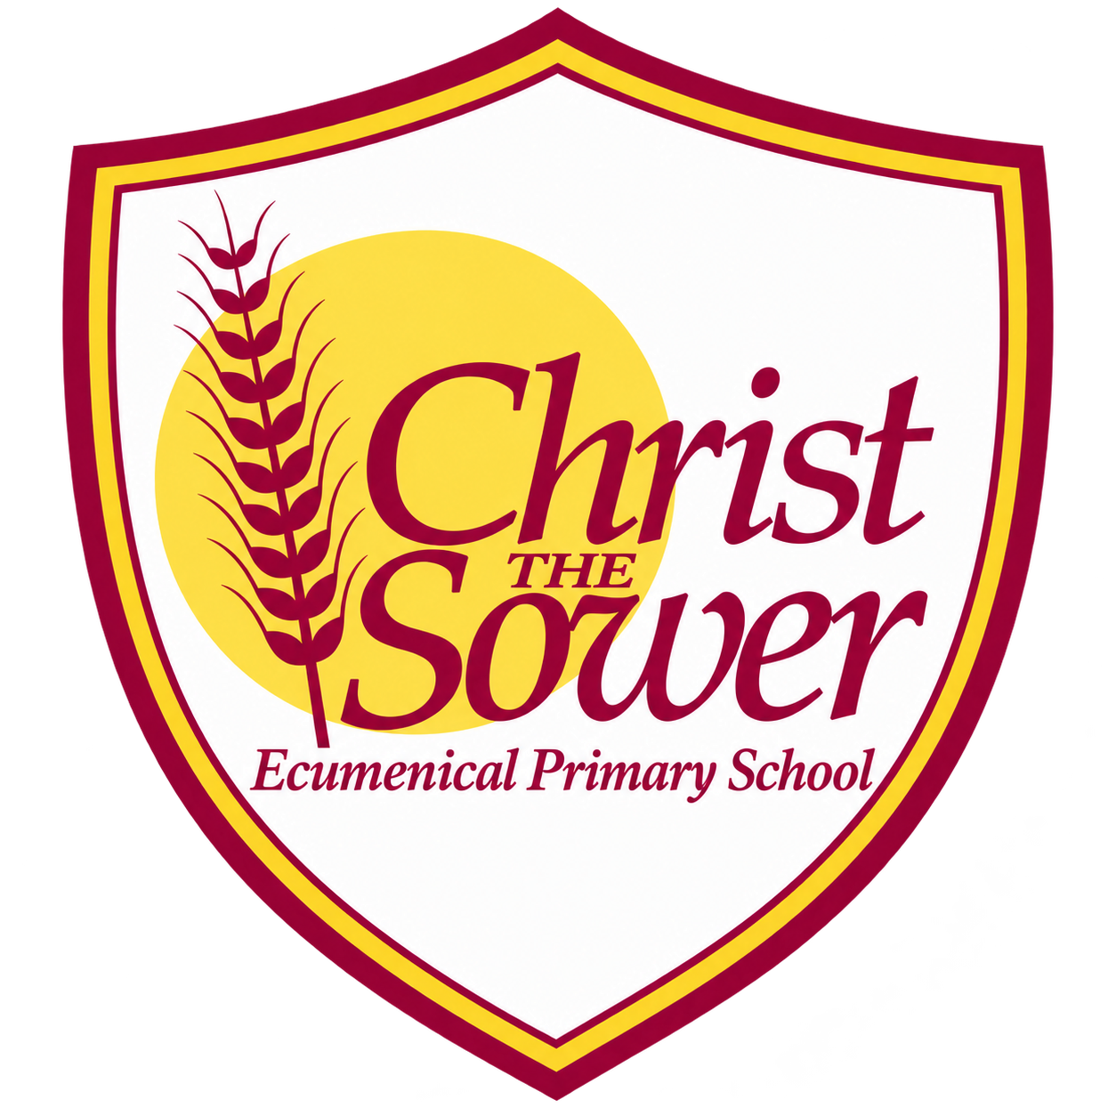 | YEAR 3 • HISTORY • SUMMER 2  Ancient Egypt | KNOWLEDGE  ORGANISER

BIG QUESTION | What was it like to live in Ancient Egypt?

 | → |  | →
  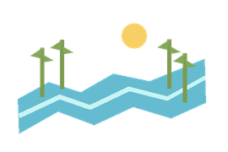 | ANCIENT EGYPT BEGINS  c. 3100 BC  Civilisation grows by the Nile
  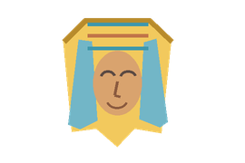 | TUTANKHAMUN RULES  c. 1330 BC  A pharaoh in Ancient Egypt
  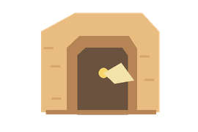 | TOMB DISCOVERED  AD 1922  Howard Carter explores the tomb

  WHAT SHOULD I KNOW?
  Who were the Ancient Egyptians? People who lived in an ancient civilisation in Egypt, beside the River Nile.
  Why was the River Nile important? The Nile provided water and helped people grow food, travel and build communities.
  What was life like? People farmed, lived in communities and had different jobs, including scribes. Pharaohs were their rulers.
  How did Egyptians write? They used a writing system made of symbols called hieroglyphs.
  Why is the Rosetta Stone important? It helped people understand and translate ancient Egyptian writing.
  Who was Tutankhamun? An Egyptian pharaoh. Howard Carter discovered his tomb and its treasures in 1922.
  What can tombs tell us? Objects buried with pharaohs give clues about their lives and beliefs about the afterlife.
  WORDS TO REMEMBER
  Civilisation a society with shared ways of living and working
  Pharaoh a ruler of Ancient Egypt
  Hieroglyphs symbols used in Egyptian writing
  Papyrus a plant used to make a writing surface
  Scribe someone trained to read and write
  Irrigation bringing water to land to help crops grow
  Tomb a place where someone is buried
  Artefact an object made or used in the past
  Archaeologist someone who studies the past through objects and remains
  HISTORY DETECTIVES
  We study writing, artefacts and accounts to understand the past and compare different interpretations.

THE NILE  Water • farming • communities | WRITING  Hieroglyphs • papyrus • scribes | LASTING LEGACY  Writing • buildings • artefacts

EVIDENCE WE EXPLORE | Hieroglyphs • Rosetta Stone • Carter’s diary • Tutankhamun’s tomb

