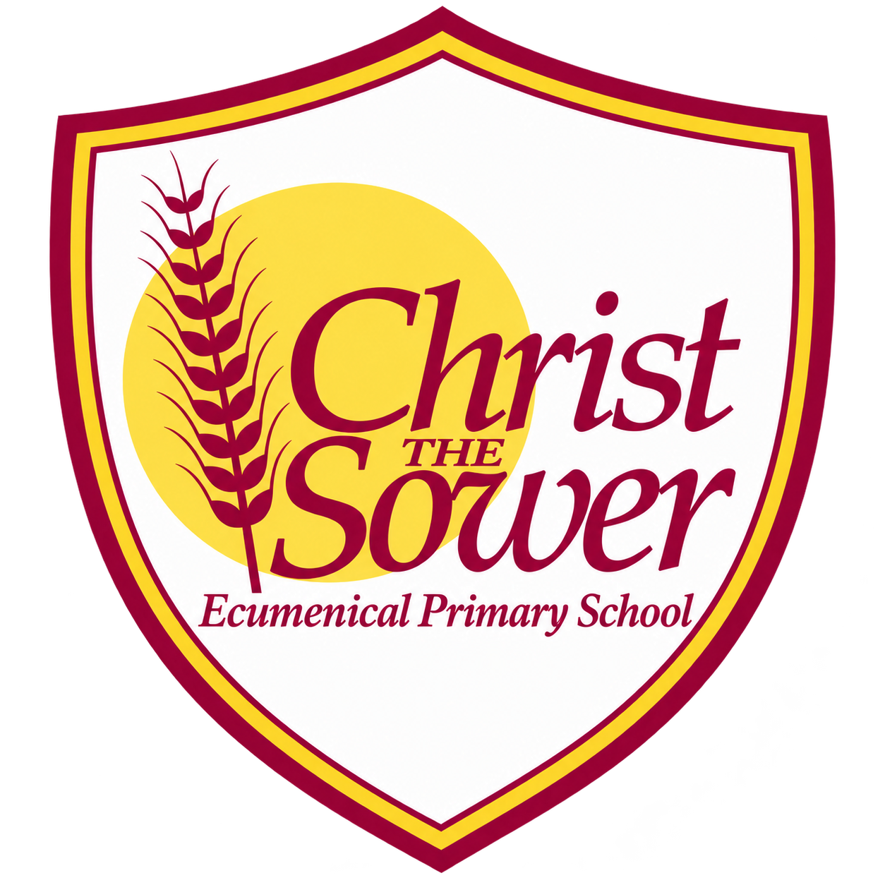 | YEAR 2 • HISTORY • SUMMER 2  Aspiring Nurses | KNOWLEDGE  ORGANISER

BIG QUESTION | What did Edith Cavell and Mary Seacole do to inspire people to become nurses?

 | → |  | →
  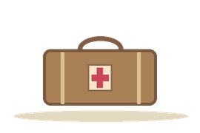 | MARY SEACOLE  1850s  Cared for people in the Crimean War
  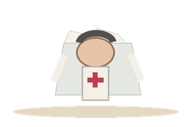 | EDITH CAVELL  First World War  Cared for soldiers and helped them escape
   | NURSES TODAY  Now  Use modern training and equipment

  WHAT SHOULD I KNOW?
  Who was Mary Seacole? A Jamaican-born woman who helped sick and injured soldiers during the Crimean War in the 1850s.
  Who was Edith Cavell? A British nurse who worked in Belgium during the First World War.
  Why is Edith Cavell remembered? She cared for soldiers from both sides and helped Allied soldiers escape.
  Why are both women significant? They are remembered for courage and caring for people during wartime.
  How has nursing changed? Nurses today use modern hospitals, medicines and equipment. Caring for patients is still important.
  How can we learn about their lives? Photographs, stories and written records can help us discover what they did.
  WORDS TO REMEMBER
  Nurse someone who cares for sick or injured people
  War fighting between countries or groups
  Significant important enough to remember
  Wounded hurt or injured
  Hospital a place where patients receive care
  Source something that tells us about the past
  Compare look for things that are alike or different
  HISTORY DETECTIVES
  Look at an old hospital photograph. What seems different from hospitals today? What stayed the same?

SIGNIFICANT PEOPLE  Two nurses • different wars | THEN & NOW  Hospitals • nursing • equipment | EVIDENCE  Photographs • written records

EVIDENCE WE EXPLORE | Photographs • Stories • Wartime accounts • Hospital images
Builds on Year 1: important people. Connects to later learning about wartime life and Black British history.

