 | YEAR 2 • HISTORY • SPRING 2  Journeys and Explorers | KNOWLEDGE  ORGANISER

BIG QUESTION | What journeys really stand out and inspire us to explore the world?

 | → |  | →
  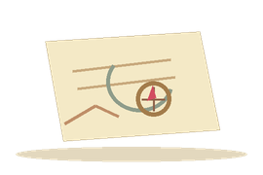 | IBN BATTUTA  1300s  Travelled and wrote about journeys
  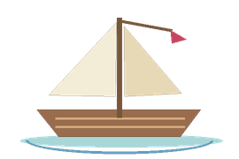 | COLUMBUS  1492  Sailed west across the Atlantic
  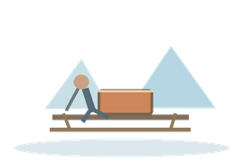 | POLAR JOURNEYS  1900s to today  Henson, Shackleton and Aston

  WHAT SHOULD I KNOW?
  Why did people explore? Explorers travelled for reasons such as learning about places, trade or reaching new routes.
  Who was Ibn Battuta? A traveller who visited many places about 700 years ago. His journeys were recorded in a book called the Rihla.
  Who was Christopher Columbus? In 1492, he sailed west hoping to reach Asia and reached parts of the Americas where people already lived.
  Who was Ernest Shackleton? He led the Endurance expedition to Antarctica. The attempt to cross the continent failed, but his crew survived.
  Who was Matthew Henson? An explorer on a North Pole expedition in 1909. His achievements were not always recognised fairly.
  Who is Felicity Aston? A modern polar explorer. Her journeys help us compare exploration now with journeys long ago.
  What has changed? Explorers today can use better equipment, communication and navigation than explorers in the past.
  WORDS TO REMEMBER
  Explorer someone who travels to learn about places
  Expedition a journey made for a particular purpose
  Journey travelling from one place to another
  Significant important enough to remember
  Evidence clues that help us learn about the past
  Polar connected with the North or South Pole
  Technology tools and equipment that help people
  HISTORY DETECTIVES
  Look at old and new exploration photographs and maps. What has changed? Whose stories might be missing?

WHEN & WHERE  Maps • journeys • timelines | CHALLENGES  Travel • risk • survival | SIGNIFICANCE  Achievements • fair recognition

EVIDENCE WE EXPLORE | Maps • Ibn Battuta’s written account • Photographs • Expedition stories
Builds on Year 1: significant people and flight. Prepares for later units about exploration and innovation.

