 | YEAR 2 • HISTORY • AUTUMN 2  The Great Fire of London | KNOWLEDGE  ORGANISER

BIG QUESTION | What caused the Great Fire of London and how did it change London?

 | → |  | →
  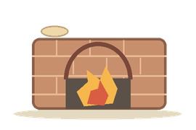 | FIRE STARTS  2 September 1666  A bakery in Pudding Lane
  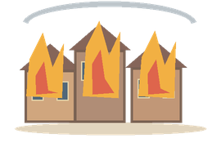 | FIRE SPREADS  September 1666  Houses and streets burn
  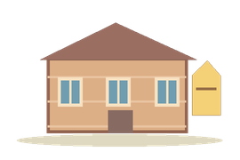 | LONDON REBUILDS  After 1666  Buildings and rules change

  WHAT SHOULD I KNOW?
  When and where did it happen? The Great Fire began in a bakery in Pudding Lane, London, in September 1666.
  Why did the fire spread? Many houses were wooden and close together. Strong wind, dry weather and limited firefighting made the fire spread quickly.
  What happened to London? Thousands of homes and many buildings burned down, leaving many people without homes.
  Who was Samuel Pepys? A man who saw the fire and wrote about it in his diary. His words are an important historical source.
  What changed after the fire? Parts of London were rebuilt. New rules encouraged buildings made with brick and stone to reduce fire risks.
  How can we investigate the fire? Diaries, pictures and old maps help us find out what happened and what changed.
  WORDS TO REMEMBER
  Bakery a place where bread is made
  Pudding Lane the London street where the fire began
  Cause why something happened
  Consequence what happened as a result
  Eyewitness someone who saw an event
  Diary a written record of what someone experienced
  Source something that tells us about the past
  HISTORY DETECTIVES
  Read an extract from Samuel Pepys’s diary. What can it tell us about the fire?

BEFORE & AFTER  London in 1666 • London now | CAUSE & RESULT  Wooden homes • fire • rebuilding | EVIDENCE  Pepys’s diary • pictures • maps

EVIDENCE WE EXPLORE | Samuel Pepys’s diary • Paintings • Old maps • Historical accounts
Builds on Year 1: timelines and sources. Prepares for later learning about causes, consequences and change.

