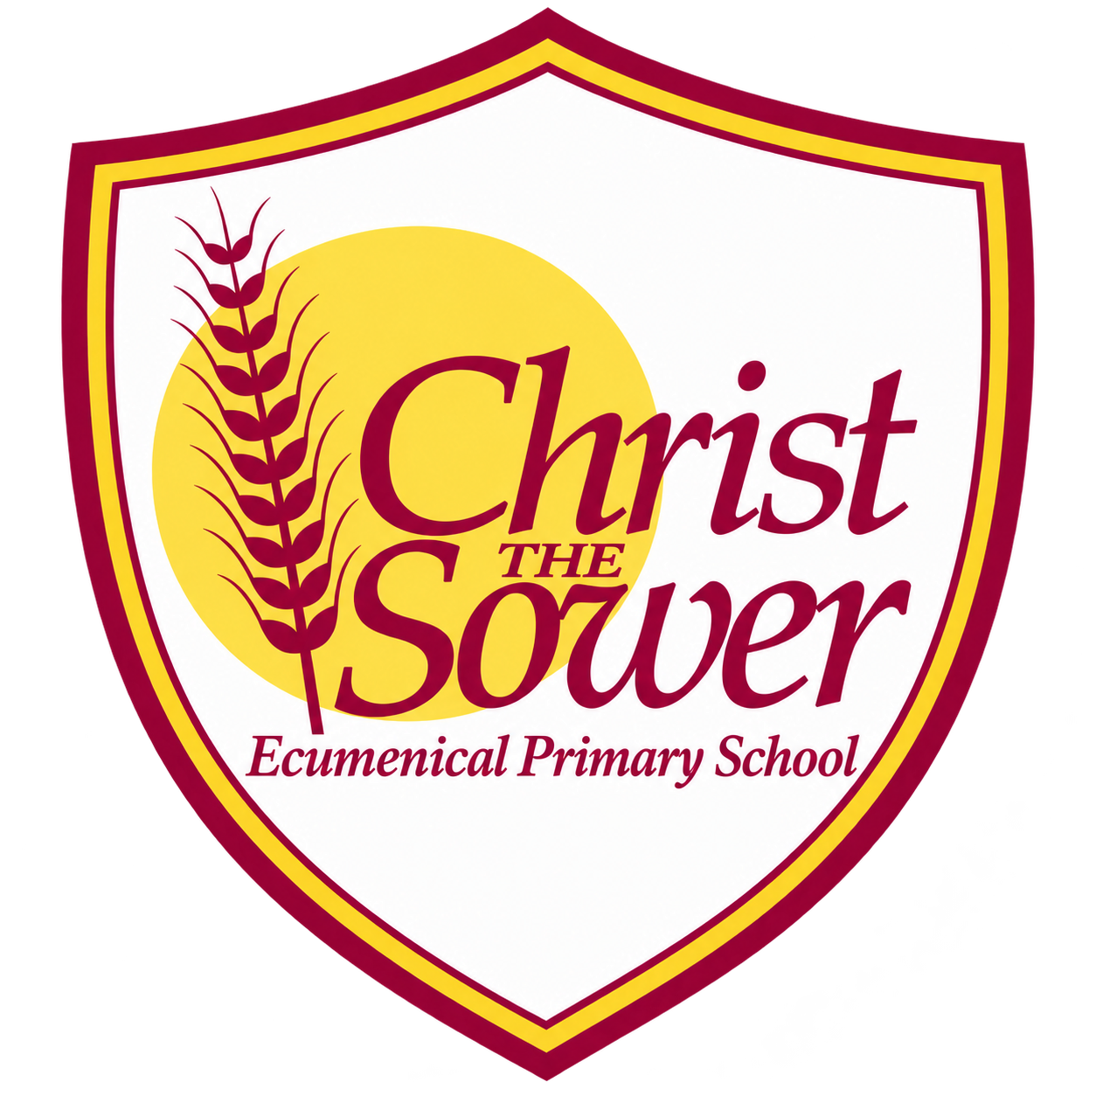 | YEAR 1 • HISTORY • AUTUMN 2  Toys Then and Now | KNOWLEDGE  ORGANISER

BIG QUESTION | How have toys changed over time?

 | → |  | →
  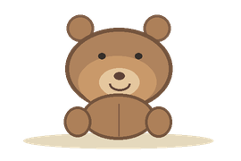 | TOYS LONG AGO  About 100 years ago  Older toys and teddy bears
  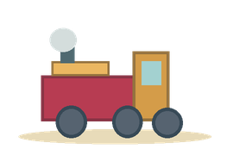 | TOYS IN LIVING MEMORY  When adults were young  Ask family about toys
  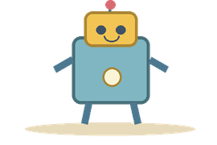 | TOYS TODAY  Now  Modern toys and games

  WHAT SHOULD I KNOW?
  What is the past? Things that have already happened. The present is what is happening now.
  How can we put things in order? A timeline shows what happened first, next and last.
  What were toys like long ago? Many were made from wood, metal or fabric. Some toys were made by hand.
  What are toys like today? Many are made from plastic or other modern materials. Some use batteries or electronics.
  What has stayed the same? Children still enjoy toys such as teddy bears, blocks and dolls.
  How do we find out about old toys? We can look at real toys and photographs and ask older people what they played with.
  WORDS TO REMEMBER
  Past something that has already happened
  Present what is happening now
  Timeline events in time order
  Compare look for things that are alike or different
  Artefact an object from the past
  Living memory a time remembered by people alive today
  Change something becomes different
  HISTORY DETECTIVES
  Look at a toy. What is it made from? Is it old or new? How can you tell?

THEN & NOW  Past • present • timeline | CHANGE & SAME  Materials • teddy bears | CLUES FROM THE PAST  Photos • objects • memories

EVIDENCE WE EXPLORE | Old photographs • Real toys • Family memories • Pictures
Builds on EYFS: talking about our own lives. Next: use timelines and evidence to learn about people and events.

