 | YEAR 1 • HISTORY • SUMMER  The History of Flight | KNOWLEDGE  ORGANISER

BIG QUESTION | Why is flight such an amazing invention?

 | → |  | →
  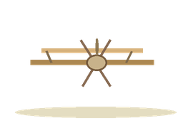 | WRIGHT BROTHERS  1903  Successful powered aeroplane flight
  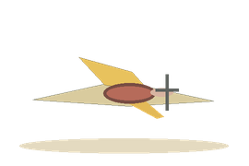 | AMY JOHNSON  1930  Solo flight to Australia
   | TIM PEAKE  2015–2016  Worked on the space station

  WHAT SHOULD I KNOW?
  What did people want to do? People tried for many years to invent ways to fly.
  Who were the Wright brothers? Orville and Wilbur Wright made the first successful controlled, powered aeroplane flight in 1903.
  Who was Amy Johnson? A pilot who became the first woman to fly alone from England to Australia in 1930.
  How did flying change? Early aeroplanes led to more advanced planes that could travel much further.
  What is an astronaut? Someone who travels into space. Tim Peake was a British astronaut on the International Space Station.
  How did flight help space travel? New flying technology and knowledge helped people develop rockets and spacecraft.
  WORDS TO REMEMBER
  Flight travelling through the air
  Inventor someone who makes something new
  Aeroplane a machine with wings that flies
  Pilot someone who flies an aircraft
  Timeline events put in time order
  Astronaut someone who travels into space
  Myth a traditional story, not a proven historical fact
  HISTORY DETECTIVES
  Look at pictures of old and new aircraft. What has changed? How can we tell?

INVENTIONS  People tried new ideas | IMPORTANT PEOPLE  Wright brothers • Amy Johnson | THEN & NOW  Aeroplanes • space travel

EVIDENCE WE EXPLORE | Old photographs • Film clips • Maps of journeys • Timelines
Builds on Toys: inventions and change. Builds foundations for Year 5 history of the Space Race.

