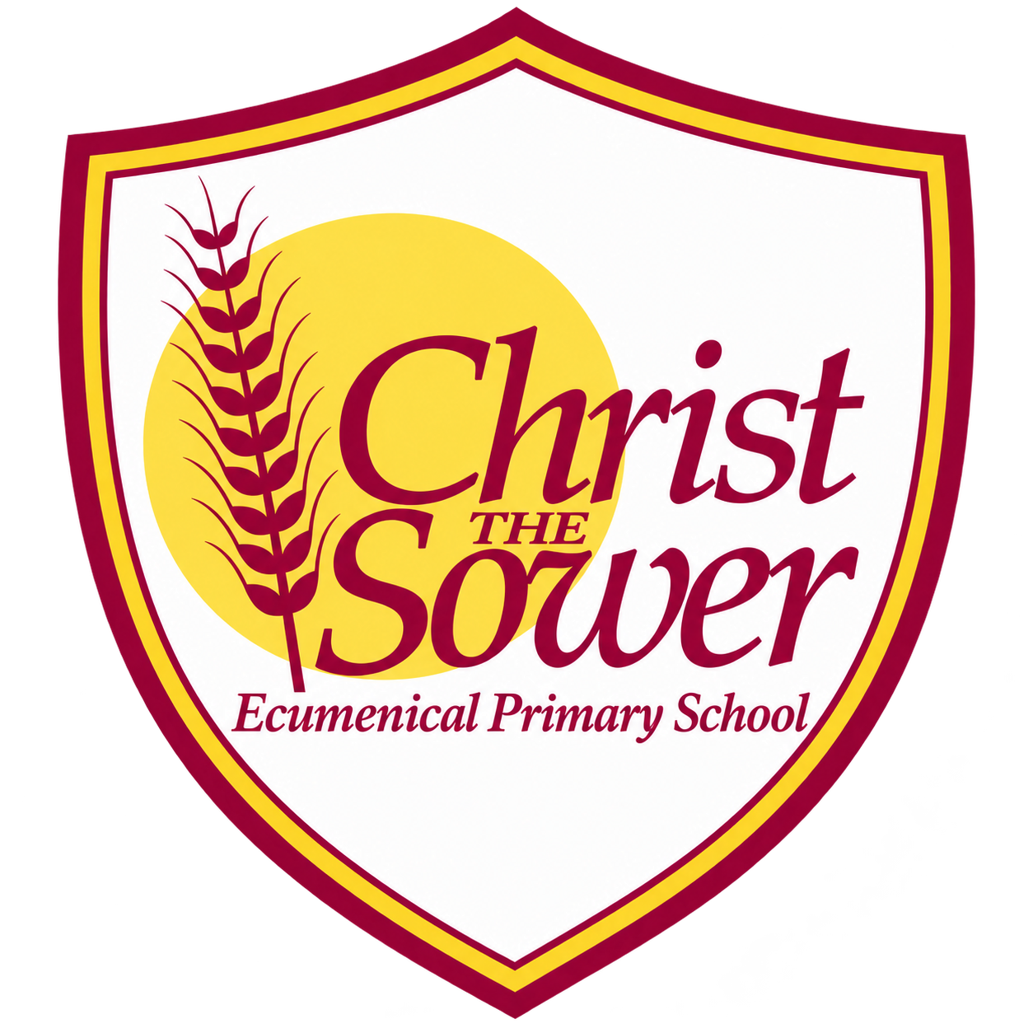 | YEAR 1 • HISTORY • SPRING 2  Monarchs: Then and Now | KNOWLEDGE  ORGANISER

BIG QUESTION | How has the role of kings and queens changed over time?

 | → |  | →
  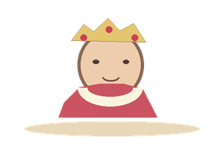 | QUEEN ELIZABETH I  1558–1603  A Tudor queen
  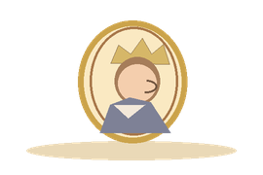 | QUEEN VICTORIA  1837–1901  The Victorian era
  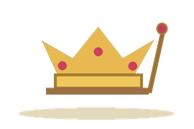 | KING CHARLES III  From 2022  Our modern monarch

  WHAT SHOULD I KNOW?
  What is a monarch? A king or queen. The British monarchy is usually passed on within a family.
  Who was Queen Elizabeth I? A queen who ruled England a long time ago, during Tudor times.
  Who was Queen Victoria? A queen who reigned in the Victorian era, from 1837 to 1901.
  Who is King Charles III? He became monarch in 2022, after Queen Elizabeth II.
  Has the monarch’s job changed? Yes. Monarchs in the past had more power. Today the monarch has important duties but does not personally make laws.
  How do we find out about monarchs? We can study portraits, objects and other clues from the past.
  WORDS TO REMEMBER
  Monarch a king or queen
  Reign the time a monarch is on the throne
  Tudor a period long before Victorian times
  Victorian the time when Queen Victoria reigned
  Portrait a picture of a person
  Coronation a special ceremony for a monarch
  Power being able to make decisions or rules
  HISTORY DETECTIVES
  Look at an old portrait. What do the clothes or objects tell us about that monarch?

TIME ORDER  Tudor • Victorian • today | POWER & ROLE  A monarch’s job can change | CLUES FROM THE PAST  Portraits • objects

EVIDENCE WE EXPLORE | Portraits • Old objects • Coronation pictures • Timelines
Builds on Toys: past and present, timelines and evidence. Prepares for Year 6 study of Victorian Britain.

