
Christ the Sower Ecumenical Primary School Pupil Premium Strategy Statement

This statement details our school’s use of pupil premium funding to help improve the attainment of our disadvantaged pupils.

It outlines our pupil premium strategy, how we intend to spend the funding in the next three academic years and the effect that last year’s spending of pupil premium had within our school.

School overview
Detail | Data
Number of pupils in school | 207
Proportion (%) of pupil premium eligible pupils | 33%
Academic year/years that our current pupil premium strategy plan covers (3year plans are recommended) | 2026-2027  2027-2028  2028-2029
Date this statement was published | September 2026
Date on which it will be reviewed | July 2027
Statement authorised by | Mel Nugent
Pupil premium lead | Tina Palfreyman
Governor / Trustee lead | Michael Morris/ Michael Mill
Funding overview
Detail | Amount
Pupil premium funding allocation this academic year  (This is based on the last census of October 2024) | £92,745
Pupil premium funding carried forward from previous years (enter £0 if not applicable) | £ 0
Total budget for this academic year (projected) | £92,745

Part A: Pupil premium strategy plan

Statement of intent
At Christ the Sower Primary School, our vision is to provide the "good earth" in which every child can flourish academically, socially and emotionally. We recognise that disadvantaged pupils can face additional barriers to success and are committed to ensuring that these barriers do not limit achievement or life opportunities.
Our Pupil Premium strategy is built around the school's priorities. We will secure excellent outcomes through high-quality teaching, precise assessment, adaptive practice and evidence-informed interventions. We will ensure that disadvantaged pupils develop strong vocabulary, communication skills, reading fluency, writing confidence and mathematical understanding so that attainment and progress are in line with, or exceed, that of their peers.
Alongside academic success, we will remove barriers connected to attendance, wellbeing, emotional regulation and participation in school life. Through trauma-informed practice, strong family partnerships and targeted pastoral support, we will ensure that disadvantaged pupils feel safe, valued and ready to learn.
We are equally committed to ensuring that every disadvantaged child benefits from a rich programme of enrichment opportunities, leadership experiences and wider curriculum activities that develop cultural capital, aspiration and belonging. Our approach is responsive to the individual needs of pupils and families and is informed by evidence from the Education Endowment Foundation and our own robust assessment and evaluation processes.

Challenges

This details the key challenges to achievement that we have identified among our disadvantaged pupils.
Challenge number | Detail of challenge
1 | Vocabulary, communication and oracy gaps, particularly for disadvantaged pupils who are also EAL. These gaps affect reading comprehension, writing quality and access to the wider curriculum.
2 | Writing attainment and progress remain lower than other core subjects. Disadvantaged pupils require targeted support with sentence construction, vocabulary development and transcription skills.
3 | Some disadvantaged pupils enter school with lower starting points and require additional intervention and adaptive teaching to secure strong outcomes in reading, writing and maths.
4 | Attendance and persistent absence are disproportionately high amongst disadvantaged pupils, reducing learning time and impacting attainment.
5 | Some disadvantaged pupils experience social, emotional, behavioural and wellbeing barriers which affect readiness to learn and engagement.
6 | Parental engagement and participation in wider enrichment opportunities are lower for some disadvantaged families, limiting cultural capital and wider experiences.

Intended outcomes
This explains the outcomes we are aiming for by the end of our current strategy plan, and how we will measure whether they have been achieved.
Intended outcome | Success criteria
Improve vocabulary, communication and oracy skills | Pupils demonstrate increased use of Tier 2 and Tier 3 vocabulary. Pupil voice, book scrutiny and assessments show improved language acquisition and communication skills.
Improve outcomes in reading, writing and maths | PP attainment and progress gaps diminish across all key stages. Greater numbers of PP pupils achieve EXS and GDS.
Improve writing outcomes | Writing outcomes improve across all year groups with increased proportions of disadvantaged pupils meeting age-related expectations.
Improve attendance and reduce persistent absence | PP attendance is at least in line with national figures and persistent absence is significantly reduced.
Improve wellbeing and readiness to learn | Pupils demonstrate improved engagement, resilience and behaviour for learning.
Increase participation in enrichment and wider opportunities | All PP pupils access enrichment opportunities, clubs, trips and leadership experiences during the academic year.
Strengthen parental engagement | Increased attendance at workshops, consultations and school events, leading to improved home-school partnership.
Activity in this academic year
This details how we intend to spend our pupil premium (and recovery premium funding) this academic year to address the challenges listed above.

Teaching (for example, CPD, recruitment and retention)
Budgeted cost: £35,000
Activity | Evidence that supports this approach | Challenge number(s) addressed
Whole-school CPD on adaptive teaching, scaffolding and assessment | EEF evidence identifies high-quality teaching as the greatest lever for improving outcomes | 1,2,3
Development of oracy and vocabulary through Colourful Semantics and CTS Oracy Framework | Oral language interventions show high impact (+6 months) | 1,2
Writing CPD, moderation and coaching | SDP identifies writing as lowest attaining subject | 2,3
Reading development including phonics transition and comprehension teaching | Reading remains a strategic priority in SDP | 1,3
Maths adaptive teaching CPD and use of manipulatives | EEF identifies mastery approaches as effective for disadvantaged pupils | 3

Targeted academic support (for example, tutoring, one-to-one support, structured interventions)
Budgeted cost: £25,000
Activity | Evidence that supports this approach | Challenge number(s) addressed
Same-day intervention and post-teaching support | Timely intervention prevents learning gaps widening | 3
Lexia reading intervention | Proven impact on literacy development | 1,3
Small group reading and fluency interventions | Reading comprehension approaches provide strong gains | 1,3
Structured maths intervention programmes | Effective targeted intervention supports misconceptions | 3
Writing intervention using Colourful Semantics and sentence-level teaching | Current school evidence shows strong impact in EYFS and Year 1 | 1,2,3

Wider strategies (for example, trips, related to attendance, behaviour, wellbeing)
Budgeted cost: £32,745
Activity | Evidence that supports this approach | Challenge number(s) addressed
Attendance support, family engagement and inclusion team work | Improved attendance leads to improved outcomes | 4,5
Trauma-informed practice and emotional wellbeing support | Supports engagement and readiness to learn | 5
Subsidised educational visits, residentials and enrichment opportunities | Improves aspiration and cultural capital | 6
Financial support for clubs, music tuition and leadership opportunities | Ensures equitable access to wider experiences | 6
Parent workshops and family learning opportunities | Increased parental engagement improves pupil outcomes | 6
Targeted pastoral and inclusion support | Addresses barriers to learning early | 4,5

Total budgeted cost: £92,745

Part B: Review of outcomes in the previous academic year

Pupil premium strategy outcomes
Review of 2025-2026 academic year.
We have analysed the performance of our disadvantaged children using our internal assessments as well as all statutory assessment outcomes data. This review evaluates the impact of our Pupil Premium strategy during the 2025-26 academic year. Throughout the year, we maintained a strong focus on closing attainment gaps, improving language and literacy outcomes, increasing mathematical fluency, improving attendance and ensuring access to enrichment opportunities. Our disadvantaged cohort remained mobile throughout the year, with significant pupil movement and a number of new arrivals presenting with additional needs, SEN and lower starting points. Despite these challenges, outcomes for many of our disadvantaged pupils were strong and, in several areas, exceeded whole-cohort performance

Christ the Sower School Primary - Statutory Assessments Outcomes 2026
Early Years Foundation Stage EYFSP GLD
All | PP
85% (22/26) | 78% (7/9)*
Seventy-eight percent of Pupil Premium pupils achieved a Good Level of Development compared with 85% overall. This represents a positive outcome when considering the context of the two pupils who did not achieve GLD. One child is on the SEN register and accesses tailored provision through our Nest provision, while the second pupil joined later in the academic year. Drawing Club continued to have a positive impact, helping develop vocabulary, communication, creativity and early writing skills.

Phonics Screening
Year 1 All | Year 1 PP | Year 2 All (including those who passed in Year 1) | Year 2 PP (including those who passed in Year 1)
90% (19/21) | 80% (8/10) | 96% | 91%
Year 1 Pupil Premium outcomes reached 80%, compared with 90% across the cohort. Context is important, as both pupils who did not meet the threshold joined the school during the year, with one presenting additional needs and the other returning to education after a period out of school. By Year 2, outcomes improved significantly, with 91% of Pupil Premium pupils meeting the expected standard. The remaining pupils who did not pass had identified SEN and speech and language needs. These outcomes demonstrate the effectiveness of targeted phonics intervention and continued support beyond Year 1.

End of Key Stage 2 Outcomes
 | Reading |  | Writing |  | Maths |  | Combined
 | EXS+ | GDS | EXS+ | GDS | EXS+ | GDS | EXS+ | GDS
CTS ALL | 81.3% | 28.1% | 93.8% | 25% | 90.6% | 28.1% | 78.1% | 9.4%
PP | 85% | 39% | 85% | 16% | 85% | 31% | 85% | 15.4%

In Year 6, 2 out of the 13 children were on part-time timetable (one SEN was full time at the PRU since Spring 1 and the other was working below KS2 and was also SEN), the outcomes for the rest of the 11/13 PP children were impressive. All of them met the expected standard in Reading, Writing and Maths. These outcomes are a significant strength within our Pupil Premium provision this year. Pupil Premium pupils outperformed the whole cohort in Reading, Maths and Combined outcomes at the Expected Standard. Reading outcomes were particularly impressive, with 85% achieving EXS+ compared with 81.3% overall, and 39% achieving Greater Depth compared with 28.1% overall. Maths outcomes were equally strong, with 85% achieving EXS+ and 31% achieving Greater Depth. Combined outcomes showed 85% of Pupil Premium pupils achieving the expected standard compared with 78.1% of the whole cohort. These outcomes reflect high-quality teaching, targeted intervention, effective booster provision and strong engagement from pupils
Multiplication Check
 | ALL | PP
Average Score | 24.5 | 24.5
Number of pupils who achieved 21 marks or greater | 27/27- 100% | 8/8- 100%
Number of pupils who achieved full (25) marks | 17/27 – 63% | 5/8- 63%

This was one of the strongest areas of performance this year. Pupil Premium pupils achieved the same average score as the whole cohort, scoring 24.5 out of 25. Every Pupil Premium child achieved 21 marks or above, and 63% achieved full marks, matching the cohort. This reflects the impact of targeted fluency work, regular practice and carefully planned support. It was particularly pleasing that one pupil with SEN and Pupil Premium status achieved full marks.

Internal Assessments
Internal assessment data is reviewed termly through pupil progress meetings. We use a broad range of evidence, including teacher assessment, pupil voice, work scrutiny and testing, to gain a complete picture of progress. Our focus is not simply on attainment but also on the progress pupils make from their starting points. Assessments inform bespoke interventions and support packages throughout the year, ensuring pupils receive timely and appropriate support.

The table for each year group demonstrates the attainment data in comparison to baseline at the beginning of the year.

Year 1
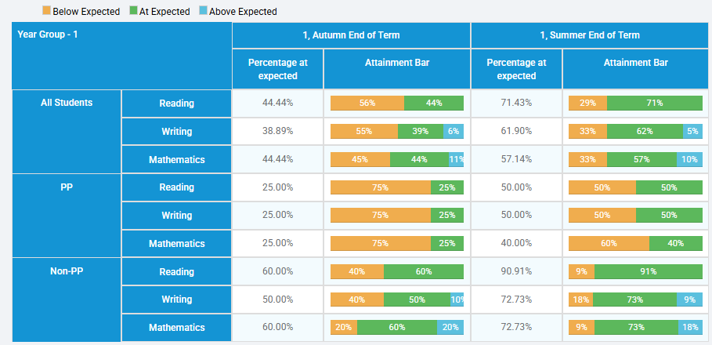
Year 2
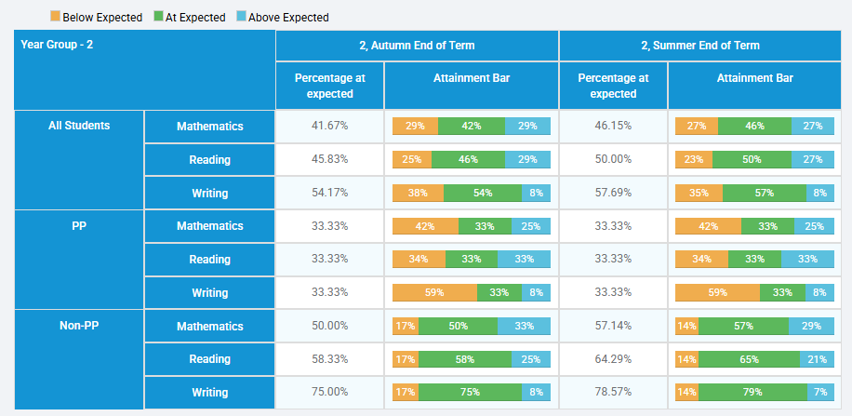

Year 3
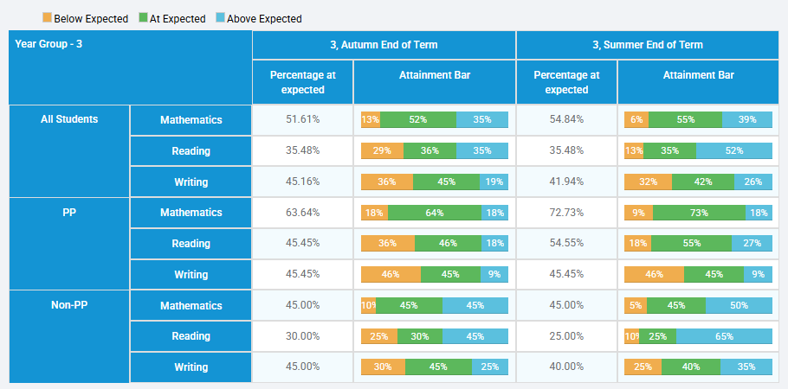

Year 4

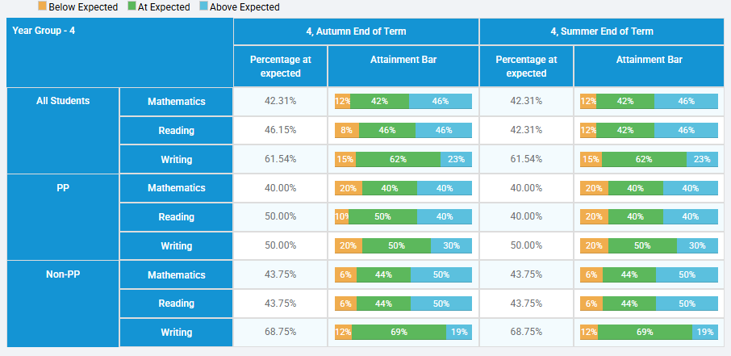

Year 5
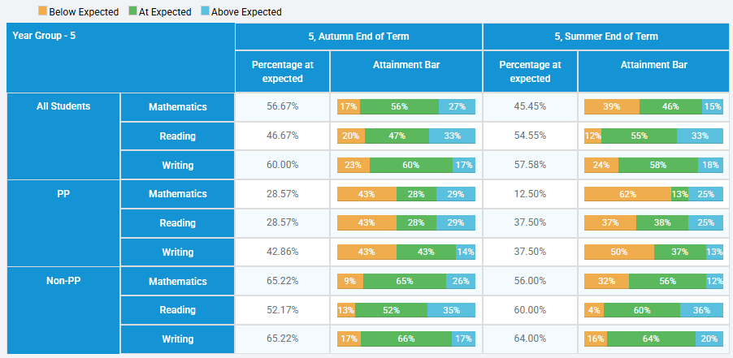

Reading: Reading has been a key priority across the school this year. Outcomes show strong attainment across year groups and an increase in pupils working at Greater Depth. Targeted support for Pupil Premium pupils has focused on vocabulary development, comprehension and reading fluency. While outcomes are positive, reducing any remaining attainment gap in reading remains a priority moving forward. We will continue to strengthen our reading culture through high-quality texts and explicit vocabulary instruction.
Writing: Writing remains a key area for development for disadvantaged pupils. It is important to note that this data reporting focuses on 59 PP (the rest are in Early Years) children from Y1- Y6. 27% are on the SEN register and 42% are EAL. Colourful Semantics has had a particularly positive impact in Year 1. Writing outcomes improved from 39% to 62% achieving the expected standard by the end of the year. Improvements in oral language and sentence construction have supported writing development. Moving forward, we intend to embed these successful approaches consistently across the school.
Maths: Maths outcomes continue to be positive across all year groups. Most year groups demonstrated increased proportions of pupils achieving Greater Depth. Pupil Premium pupils have benefited from targeted fluency practice and arithmetic homework. Same-day intervention and pre-teaching or post-teaching opportunities have helped address misconceptions quickly. The success of the MTC outcomes provides further evidence that our fluency strategy is having a positive impact.
*Throughout the year, pupil mobility significantly affected the Pupil Premium cohort. Several pupils who left were working at the expected standard, while many incoming pupils arrived with SEN or lower starting points. These changes inevitably influenced some headline outcomes. Despite this, we maintained a strong focus on assessing needs quickly and implementing appropriate provision. This remains a key priority moving into the next academic year.

Summary of intended outcomes
At the end of the academic year there were 75 pupils eligible for Pupil Premium. Within that group, 24% were identified as SEN and 43% had EAL. Despite considerable complexity within the cohort, outcomes demonstrate that disadvantaged pupils are achieving well. The strongest impact can be seen in KS2 outcomes, reading attainment, mathematical fluency, MTC outcomes and targeted early literacy interventions. The evidence suggests that our tiered approach to quality-first teaching, targeted support and wider enrichment has been effective.
Attendance remains an ongoing focus. Pupil Premium attendance was approximately 93%, compared with whole-school attendance of 94.6%. While this remains below national figures, robust systems are in place. The Inclusion Lead maintains close oversight and strong relationships with families. Interventions include meetings, attendance letters, personalised support and early identification of concerns. Our aim remains to further reduce persistent absence during 2026-27
Enrichment continues to be a significant strength of our Pupil Premium offer. More than 75% of Pupil Premium pupils participated in a sports academy or after-school club, while over 25% represented the school in festivals or competitions. Eleven Year 6 pupils graduated from the Brilliant Programme. These opportunities help develop confidence, aspiration, resilience and cultural capital, ensuring equitable access to enrichment opportunities remains a priority.
Aims for the academic year ahead 2026-2027
Our priorities for the coming academic year are clear.
- We will strengthen writing outcomes through improved assessment, moderation and targeted teaching.
- We will ensure enrichment participation is carefully tracked and barriers to participation are removed.
- We will continue our drive to improve attendance and reduce persistent absence.
- Alongside these priorities, we will maintain our focus on early language development, reading fluency and mathematical understanding so that disadvantaged pupils continue to thrive and achieve highly.

Externally provided programmes
Please include the names of any non-DfE programmes that you purchased in the previous academic year. This will help the Department for Education identify which ones are popular in England.
Programme | Provider
WRInc | Ruth Miskin Training
Lexia | Rosetta Stone
TT Rockstars | Maths Circle

Further Information (optional)
Use this space to provide any further information about your pupil premium strategy. For example, about your strategy planning, or other activity that you are implementing to support disadvantaged pupils, that is not dependent on pupil premium or recovery premium funding.

