


Christ the Sower SEND Information Report 2026-27
Vision statement

At Christ the Sower Ecumenical Primary School we provide the ‘good earth’
for all our children to flourish and achieve their full potential; so that every child
can learn and explore who they are created to be. With the highest of
expectations we, individually and collectively,
will care for, nurture and develop each and every child so that they can grow
into their God-given potential.

Through our culture of CARE (Choices, Aspiration, Reflection and Engagement) and our Christian values we create:.

A loving place where we all care, learn and grow together.

Members of staff responsible:

Headteacher: Ms Mel Nugent
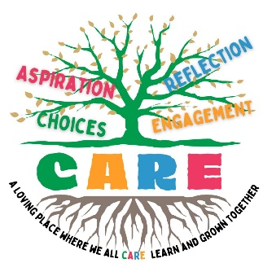
SEND Governor: Rev Mike Morris

SENDCo: Mrs Alison Summerfield

Inclusion and Well-Being Lead: Mrs Mandy Robertson

Email: school@cts.odbst.org

At Christ the Sower Ecumenical Primary School we endeavour to meet the needs of all children so that each is able to reach their full potential. We are an inclusive school and aim to meet the needs of children through highly effective teaching and learning as well as a nurturing, caring approach that is based on our Christian values and ethos.
We recognise that some children may need additional support in order to reach their goals and make the good progress that we want for all. Additional support can take many forms and we ensure that provision is tailored to individual need within our school capacity. Rigorous monitoring of learning is a core part of our work, and this ensures that we are able to identify any potential underachievement or difficulty early on.
Christ the Sower is a mainstream school and a member of the ODBST academy group. We provide for children with a wide range of Special Educational Needs and/or Disabilities. Children are able to join our Early Years setting, and other year groups where possible, without reference to ability or aptitude and we follow the admissions procedures of the ODBST.
This information report should be read alongside our school policy for SEND which can be found on our website www.cts.milton-keynes.sch.uk/

How does Christ the Sower know that pupils need extra help and what should I do if I think my child has special needs?
Identification
As detailed by the Code of Practice 2015 (including 2020 updates), a child presents with possible SEND when they are demonstrating:
- A significantly greater difficulty in learning than their peers
- A disability that prevents or hinders them from making use of the facilities in their setting
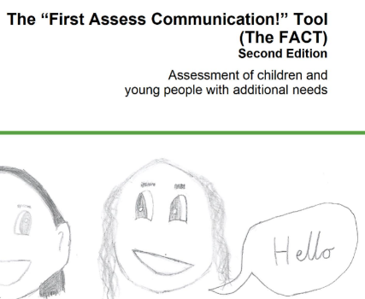
Throughout the academic year class teachers undertake a range of assessments to monitor the progress of all children. Termly pupil progress meetings are held each term to discuss these assessments and to track learning for all children. Pupil progress meetings are held with senior leaders, including the SENDCo, and class teachers to focus on any child who is making less progress than their peers and a range of strategies and catch-up interventions are put in place to address this.

A FACT assessment (First Assess Communication tool) is Milton Keynes’ first base assessment tool, and this can lead to a further assessment using FACT+ (additional social communication needs). This is usually carried out by the class teacher and is discussed with the SENDCo. FACT assessments look at learning through communication and learning behaviours and give clear pointers for what additional help might be appropriate.
In addition, the Ordinarily Available Provision documents from Milton Keynes provide a reference point for planning reasonable adjustments as well as targeted support.
Parents and carers know their children well and at Christ the Sower we encourage parents/carers to come in and talk to us about any concerns they have about their child and their development. Children are not always the same at home as they are in school, and we strive to work in partnership with parents/carers to ensure we have a full and clear picture.
The four broad areas of need that are covered by the Code of Practice and are recognised by our school are:
- Communication and Interaction
- Cognition and learning
- Social, emotional and mental health
- Sensory and/or physical needs
These areas give a broad overview, but a child might have difficulties that present in more than one area and a difficulty in one area can impact on progress in another area.
The needs of an individual child can and do change over time and so recognition of this is important; regular monitoring and assessment plays a significant role in the early identification of additional needs.
There are currently (Sept 2026) 28 children on our SEND register and of those 2 hold an EHCP.
Interventions and Monitoring
This school runs a range of interventions for children with a sound research base which enable us to closely track their effectiveness. Interventions cover all aspects of need and children generally follow them for a 12-week period followed by a review. Adaptations are made to the classroom environment to meet the needs of specific children; specialist items and resources are available for children according to need and specialist advice and the use of IT to support learning are also part on individual plans for children.
We have a small number of additional rooms that enable teachers to plan for small group work and to set up personalised learning environments for pupils who sometimes require greater adaptations and adjustments.
All additional intervention is monitored closely to ensure that it meets the needs of children and that it is accelerating progress. This can be academic progress but may also be enhanced well-being and improved levels of confidence.

In what ways are staff trained and expertise sourced and utilised to support children with SEND?

This school has a commitment to providing professional development for all staff. In order to maintain and develop the quality of teaching and provision, all staff undertake regular training. The SENDCo regularly leads and organises training to share best practice and implement new strategies and initiatives. All staff are able to access external training and have access to external agency advice.
We have completed the PINs project (Partnership for inclusion of neurodiversity in schools programme). This enabled staff to strengthen knowledge and skills as well as improve environments to better meet the needs of all children, with a particular focus on neurodivergence. All teaching and support staff were able to participate in high quality training about neurodiversity. The project also strengthened partnerships with parents and carers, supported by PACA MK (parents and carers of children with disabilities or additional needs).
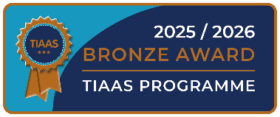
During 2025-2026, we took part in the Making Connections project and achieved the ARC Bronze Award. This project helped staff to better understand and use attachment aware and trauma responses supported by MK Educational Psychologists and the Virtual school.
The Local Offer is a directory of information that helps families to find and access support. All local authorities are required to have their own local offer as part of the government’s SEND reforms. The Local Offer for Milton Keynes can be found on the following website:

Milton Keynes City Council (mksendlocaloffer.co.uk)

How to navigate the SEND LO Power point - YouTube

How does the school work with Health and Social Care bodies, the local authority support services, and voluntary sector organisations to meet the needs of SEND children and give support to their families?

At Christ the Sower Ecumenical Primary School we work in partnership with services to meet the needs of our SEND children and families:
- Inclusion Specialist Teaching Team
- Sensory Team – including Teachers of the deaf, Teachers of Vision Impairment
- Child Protection Services
- Children and Family Practitioners
- School Nurse
- CAMHS (Child and Adolescent Mental Health Services)
- Community Paediatrics
- Occupational Therapy
- Speech and Language Therapy
- Physiotherapy
- Educational Psychologists
- Mental health schools team
Where appropriate the school will make referrals to other agencies including health and social care, voluntary and community groups and MK support services in order to meet the needs of SEN pupils and their families.


We also work with SENDIAS, a parent support body who give impartial advice to parents/carers around managing SEN provision.
SENDIAS: 01908 254518 from 9.30am to 4.30pm, Monday to Friday (answer machine facility)
SEND Information, Advice & Support Service | MK SENDIAS Enquiry Form | MK SENDIAS
Email: contact@mksendias.org.uk
www.facebook.com/MKSENDIAS
Post: MK Special Educational Needs and Disabilities Information, Advice and Support Service
Civic Offices, 1, Saxon Gate East, Milton Keynes, MK9 3EJ

What provision does the school make to support emotional and social development?
At Christ the Sower our Inclusion and Well-being Lead, Mrs Robertson, works closely with the SENDCo, class teachers and teaching assistants to ensure that children feel happy and safe in school. Mrs Robertson is a trained mental health lead and trauma informed practitioner. She liaises closely with parents/carers and outside agencies to support any additional social, emotional and mental health difficulties. She also monitors children’s attendance and provides support to parents where there are concerns to prevent prolonged or repeated absence. We aim to teach children to become respectful, resilient and mindful of others’ thoughts and feelings through a consistent approach to expectations of behaviour across all year groups. Bullying is not acceptable in the school towards any child but especially not towards those children with SEND.
Our behaviour policy, anti-bullying policy and control and restraint policy are all available on our website. www.cts.milton-keynes.sch.uk
The Governing Body review the effectiveness of the school’s liaison with other agencies when looking at the progress of pupils.

What is the school’s approach to teaching children with SEND?

Adaptations to the Curriculum and the Learning Environment
All children have access to a broad and balanced curriculum and teachers set high expectations for every child. Lessons are planned to address potential areas of difficulty and to remove barriers to achievement. SEND pupils are taught within the classroom with the curriculum and learning environment adapted to meet their needs. In most cases, such planning will mean that pupils with SEND will have full access to the National Curriculum. Additional group work is put in place to provide further support for learning, and this may have an academic focus around Maths and English or a more social and pastoral focus around developing social relationships and communication skills. This enables our SEND children to remove barriers to learning that otherwise mean they are unable to succeed.
We also strive to ensure that SEND children can fully participate in extra-curricular activities. All staff, including those bought in from external providers, are kept well informed about the strategies needed to manage children’s needs effectively and to ensure that other children understand and respond sensitively.
Some children require a more personalised approach to learning, and this might take the form of 1:1 or small group provision and intervention. Children with Sensory needs have access to a Sensory Room. These children have greater levels of need and usually, but not exclusively, will have an EHCP or a personal healthcare plan.
Other adjustments may be in the form of word processors, iPads, vocabulary banks, word maps and practical Maths resources, or more specific support equipment often pertaining to health needs.
The school building is fully wheelchair accessible including two lifts to reach the upper level and two ramps to access the higher levels of the school grounds. There are disabled toilets around the building and a shower for pupils who have additional medical needs that necessitate this facility.
Advice from external agencies is welcomed to further develop and train staff in the adaptations of lessons and the provision of more specialist interventions. All support aims to encourage as much independence as possible within a safe and caring environment for all.
The school has a Notional SEN budget each year. This funding is used to provide additional support or resources to support children with special educational needs and disabilities that might include:

• Providing specialist equipment (e.g. use of ICT, sloping board)
• Providing additional intervention programmes to help a child learn and progress
• Providing in class support aimed at increasing skills in specific areas (e.g. learning behaviours, organisation)
• Providing implementation of strategies from support agencies (e.g. behaviour support, emotionally based school avoidance)

Children with an EHCP have a budget allowance that is in addition to the whole school budget.
The Governing Body reviews the spending of the school SEN budget to ensure it is directed appropriately and that it secures progress for children with SEND.

How does the school evaluate the effectiveness of its SEND strategies?

The Headteacher is the designated responsible person in overall charge of the management of SEND provision and its resourcing. The Headteacher works closely with the SENDCo. The designated SEND Governor will keep an overview of the SEND provision being made, by meeting with the SENDCo each term. The Governing Body in conjunction with the Headteacher, have responsibility for the school's general policy and approach to provision for SEND children including the allocation of resources.

What arrangements does the school have for parents to report complaints?

If you wish to make a complaint about any aspect of the SEND provision at Christ the Sower School, please do so by consulting the procedures detailed in our Complaints Policy. This can be found on our school website www.cts.milton-keynes.sch.uk

If you have any concerns regarding your child, please speak to the class teacher in the first instance. They will be happy to arrange an appointment at a mutually convenient time.

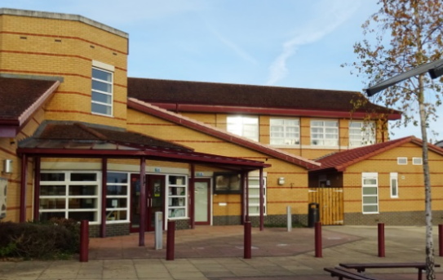
You can also contact:

SENDCo: Mrs Summerfield – 01908 867356
usual working days Monday to Wednesday.
school@cts.odbst.org

Policy date: September 2026
Review date: September 2027

