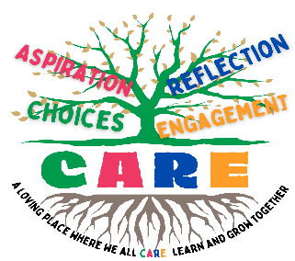
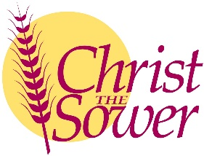
Christ the Sower Ecumenical Primary School
Science Progression of Skills and Knowledge Overview

States of Matter
National Curriculum Aims |  | Progression in Skills | Progression in Knowledge
Early learning goal | Children know about similarities and differences in relation to places, objects, materials and living things. They talk about the features of their own immediate environment and how environments might vary from one another. They make observations of animals and plants and explain why some things occur and talk about changes.
Year 1
Year 2
Year 3
Year 4 | - Compare and group materials together, according to whether they are solids, liquids or gases. Observe that some materials change state when they are heated or cooled, and measure or research the temperature at which this happens in degrees Celsius (°C).  - Identify the part played by evaporation and condensation in the water cycle and associate the rate of evaporation with temperature. | - Group and sort materials into solids, liquids or gases.  - Observe and explain that some materials change state when they are heated or cooled and measure or research the temperature in degrees Celsius (˚C) at which materials change state.  - Describe the water cycle using words or diagrams and explain the part played by evaporation and condensation. | - Materials can be grouped according to whether they are solids, liquids or gases.  - Solids stay in one place and can be held.  - Some solids can be squashed, bent, twisted and stretched. Examples of solids include wood, metal, plastic and clay.  - Liquids move around (flow) easily and are difficult to hold. Liquids take the shape of the container in which they are held. Examples of liquids include water, juice and milk.  - Gases spread out to fill the available space and cannot be held. Air is a mixture of gases.  - Heating or cooling materials can bring about a change of state. This change of state can be reversible or irreversible.  - The temperature at which materials change state varies depending on the material.  - Water changes state from solid (ice) ⇌ liquid (water) at 0°C and from liquid (water) ⇌ gas (water vapour) at 100°C. The process of changing from a solid to liquid is called melting.  - The reverse process of changing from a liquid to a solid is called freezing.  - The process of changing from a liquid to a gas is called evaporation. The reverse process of changing from a liquid to a solid is called freezing.  - The process of changing from a liquid to a gas is called evaporation. The reverse process of changing from a gas to a liquid is called condensation.  - The water cycle has four stages: evaporation, condensation, precipitation, collection.  - Water in lakes, rivers and streams is warmed by the Sun, causing the liquid water to evaporate and rise into the air as water vapour. As the water vapour rises, it cools and condenses to form liquid water droplets in clouds. The clouds become full of water, until the water falls back to the ground as precipitation (rain, hail, snow and ice).  - The fallen water collects back in lakes, rivers and streams. Evaporation and condensation are caused by temperature changes.
Year 5
Year 6

