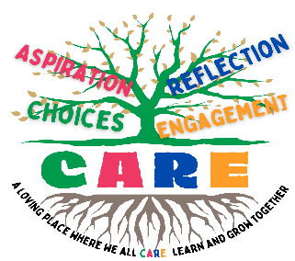
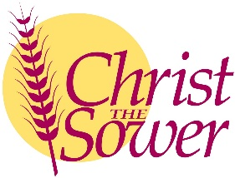
Christ the Sower Ecumenical Primary School
Science Progression of Skills and Knowledge Overview

Sound
National Curriculum Aims |  | Progression in Skills | Progression in Knowledge
Early learning goal | Children know about similarities and differences in relation to places, objects, materials and living things. They talk about the features of their own immediate environment and how environments might vary from one another. They make observations of animals and plants and explain why some things occur and talk about changes.
Year 1
Year 2
Year 3
Year 4 | - Identify how sounds are made, associating some of them with something vibrating.  - Recognise that vibrations from sounds travel through a medium to the ear.  - Find patterns between the pitch of a sound and features of the object that produced it.  - Find patterns between the volume of a sound and the strength of the vibrations that produced it.  Recognise that sounds get fainter as the distance from the sound source increases. | - Explain how sounds are made and heard using diagrams, models, written methods or verbally.  - Compae and find patterns in the pitch of a sound, using a range of equipment, such as musical instruments.  - Compare how the volume of a sound changes at different distances from the source. | - When an instrument is played, the air around or inside it vibrates. These vibrations travel as a sound wave.  - Sound waves travel through a medium, such as air or water, to the ear.  - Pitch is how high or low a sound is.  - Parts of an instrument that are shorter, tighter or thinner produce high pitched sounds. Parts of an instrument that are longer, looser or fatter produce low pitched sounds.  - Volume is how loud or quiet a sound is.  - The harder an instrument is hit, plucked or blown, the stronger the vibrations and the louder the sound.  - Sounds are louder closer to the sound source and fainter as the distance from the sound source increases.
Year 5
Year 6

