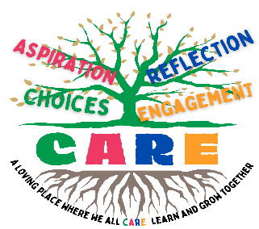
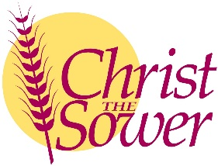
Christ the Sower Ecumenical Primary School
Science Progression of Skills and Knowledge Overview

Seasonal Changes
National Curriculum Aims |  | Progression in Skills | Progression in Knowledge
Early learning goal | Children know about similarities and differences in relation to places, objects, materials and living things. They talk about the features of their own immediate environment and how environments might vary from one another. They make observations of animals and plants and explain why some things occur and talk about changes.
Year 1 | - Observe changes across the four seasons.  - Observe and describe weather associated with the seasons and how day length varies. | - Observe changes across the four seasons.  - Observe and describe weather associated with the seasons and how day length varies.  - Observe and describe different types of weather. | - There are four seasons: spring, summer, autumn and winter. Certain events and weather patterns happen in different seasons.  - Day length (the number of daylight hours) is longer in the summer months and shorter in the winter months.  - Different types of weather include sun, rain, hail, wind, snow, fog, lightning, storm and cloud.  - The weather can change daily and some weather types are more common in certain seasons, such as snow in winter.
Year 2
Year 3
Year 4
Year 5
Year 6

