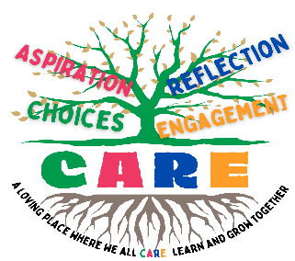
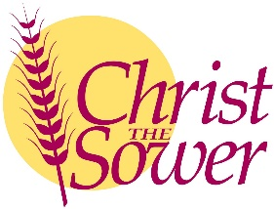
Christ the Sower Ecumenical Primary School
Science Progression of Skills and Knowledge Overview

Rocks
National Curriculum Aims |  | Progression in Skills | Progression in Knowledge
Early learning goal | Children know about similarities and differences in relation to places, objects, materials and living things. They talk about the features of their own immediate environment and how environments might vary from one another. They make observations of animals and plants and explain why some things occur and talk about changes.
Year 1
Year 2
Year 3 | - Compare and group together different kinds of rocks on the basis of their appearance and simple physical properties.  - Describe in simple terms how fossils are formed when things that have lived are trapped within rock.  - Recognise that soils are made from rocks and organic matter. | - Compare and group rocks based on their appearance, properties or uses.  - Describe simply how fossils are formed, using words, pictures or a model.  - Investigate soils from the local environment, making comparisons and identifying features. | - There are three different rock types: sedimentary, igneous and metamorphic.  - Sedimentary rocks form from mud, sand and particles that have been squashed together over a long time to form rock eg. sandstone and limestone.  - Igneous rocks are made from cooled magma or lava. They usually contain visible crystals eg. pumice and granite.  - Metamorphic rocks are formed when existing rocks are heated by the magma under the Earth’s crust or squashed by the movement of the Earth’s tectonic plates. They are usually very hard eg. slate and marble.  - Fossils form over millions of years and are the remains of a once-living organism, preserved as rock.  - Scientists can use fossils to find out what life on Earth was like in prehistoric times.  - Fossils form when a living thing dies in a watery environment. The body gets covered by mud and sand and the soft tissues rot away. Over time, the ground hardens to form sedimentary rock and the skeletal or shell remains turn to rock.  - Soils are made from tiny pieces of eroded rock, air and organic matter.  - There are a variety of naturally occurring soils including clay, sand and silt.  - Different areas have different soil types.
Year 4
Year 5
Year 6

