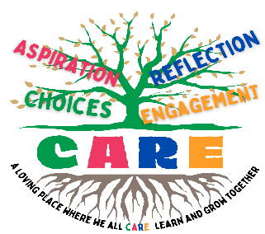
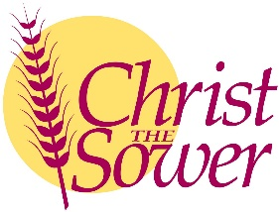
Christ the Sower Ecumenical Primary School
Science Progression of Skills and Knowledge Overview

Plants
National Curriculum Aims |  | Progression in Skills | Progression in Knowledge
Early learning goal | Children know about similarities and differences in relation to places, objects, materials and living things. They talk about the features of their own immediate environment and how environments might vary from one another. They make observations of animals and plants and explain why some things occur and talk about changes.
Year 1 | - Identify and name a variety of common wild and garden plants, including deciduous and evergreen trees.  - Identify and describe the basic structure of a variety of common flowering plants, including trees. | - Identify, compare, group and sort a variety of common plants, including deciduous and evergreen trees, based on observable features.  - Label and describe the basic structure of a variety of common plants. | - Plants are living things. Common plants include the daisy, poppy and buttercup.  - Trees are large, woody plants and are either evergreen or deciduous.  - Trees that lose their leaves in the autumn are called deciduous trees (e.g. oak, beech and rowan).  - Trees that keep their leaves all year round are called evergreen trees (e.g. holly and pine).  - The basic plant parts include root, stem, leaf, flower, petal, fruit, seed and bulb.  - Trees have a woody stem called a trunk.
Year 2 | - Observe and describe how seeds and bulbs grow into mature plants.  - Find out and describe how plants need water, light and a suitable temperature to grow and stay healthy. | - Observe and describe how seeds and bulbs change over time as they grow into mature plants.  - Describe how plants need water, light and a suitable temperature to grow and stay healthy. | - Plants grow from seeds and bulbs. Seeds and bulbs need nutrients from soil, water and warmth to start growing (germinate).  - As the plant grows bigger, it develops leaves and flowers. Plants need water, light and a suitable temperature to grow and stay healthy. Without any one of these, they will die.
Year 3 | - Identify and describe the functions of different parts of flowering plants: roots, stem/trunk, leaves and flowers.  - Explore the requirements of plants for life and growth (air, light, water, nutrients from soil, and room to grow) and how they vary from plant to plant.  - Investigate the way in which water is transported within plants.  - Explore the part that flowers play in the life cycle of flowering plants, including pollination, seed formation and seed dispersal. | - Name and describe the functions of the different parts of flowering plants (roots, stem, leaves and flowers).  - Describe the requirements of plants for life and growth (air, light, water, nutrients and room to grow) and how they vary from plant to plant. Investigate how water is transported within plants. Draw and label the life cycle of a flowering plant. | - The plant's roots anchor the plant in the ground and transport water and minerals from the ground to the plant. The stem (or trunk) supports the plant above the ground. The leaves collect energy from the Sun and make food for the plant.  - Flowers make seeds to produce new plants.  - Different plants have different needs depending on their habitat. Examples include cacti, which need less water than is typical and ferns, which can grow in lower light levels.  - Water is transported in plants from the roots, through the stem and to the leaves, through tiny tubes called xylem.  - Flowers are important in the life cycle of flowering plants.  - The stages of a plant's life cycle include germination, flower production, pollination, fertilisation, seed formation and seed dispersal. Insects and the wind can transfer pollen from one plant to another (pollination).  - Animals, wind, water and explosions can disperse seeds away from the parent plant (seed dispersal)
Year 4
Year 5
Year 6

