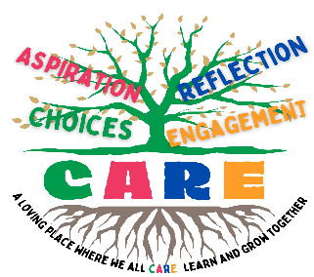
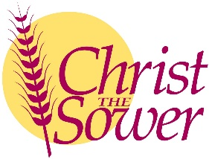
Christ the Sower Ecumenical Primary School
Science Progression of Skills and Knowledge Overview

Light
National Curriculum Aims |  | Progression in Skills | Progression in Knowledge
Early learning goal | Children know about similarities and differences in relation to places, objects, materials and living things. They talk about the features of their own immediate environment and how environments might vary from one another. They make observations of animals and plants and explain why some things occur and talk about changes.
Year 1
Year 2
Year 3 | - Recognise that they need light in order to see things and that dark is the absence of light.  - Notice that light is reflected from surfaces.  - Recognise that light from the sun can be dangerous and that there are ways to protect their eyes.  - Recognise that shadows are formed when the light from a light source is blocked by an opaque object.  - Find patterns in the way that the size of shadows change. | - Describe dark as being the absence of light and that we need light to be able to see.  - Group and sort materials as being reflective or non-reflective.  - Explain why light from the sun can be dangerous.  - Explain, using words or diagrams, how shadows are formed when a light source is blocked by an opaque object.  - Find patterns in the way shadows change during the day. | - Dark is the absence of light, and we need light to be able to see.  - Light can be reflected from different surfaces.  - Some surfaces are poor reflectors, such as some fabrics, while other surfaces are good reflectors, such as mirrors.  - Light from the Sun is damaging for vision and the skin.  - Protection from the Sun includes sun cream, sun hats, sunglasses, staying indoors or in the shade.  - A shadow is formed when light from a light source, such as the Sun, is blocked by an opaque object.  - Transparent objects allow light to pass through them and do not create shadows.  - Shadows change shape and size when the light source moves e.g. when the light source is high above the object, the shadow is short and when the light source is low down, the object's shadow is long.
Year 4
Year 5
Year 6 | - Recognise that light appears to travel in straight lines.  - Use the idea that light travels in straight lines to explain that objects are seen because they give out or reflect light into the eye.  - Explain that we see things because light travels from light sources to our eyes or from light sources to objects and then to our eyes.  - Use the idea that light travels in straight lines to explain why shadows have the same shape as the objects that cast them. | - Identify those light travels in straight lines.  - Explain that, due to how light travels, we can see things because they give out or reflect light into the eye.  - Explain, using words, diagrams or a model, why shadows have the same shape as the objects that cast them and how shadows can be changed. | - Light travels in straight lines.  - Light sources give out light. They can be natural or artificial.  - When light hits an object, it is absorbed, scattered, reflected or a combination of all three.  - Light from a source, or reflected light, enters the eye.  - Vertebrates, such as mammals, birds and reptiles, have a cornea and lens that refracts light that enters the eye and focuses it on the nerve tissue at the back of the eye, which is called the retina.  - Once light reaches the retina, it is transmitted to the brain via the optic nerve.  - A shadow appears when an object blocks the passage of light.  - Apart from some distortion or fuzziness at the edges, shadows are the same shape as the object.  - The distortion or the fuzziness depends on the position or type of light source.

