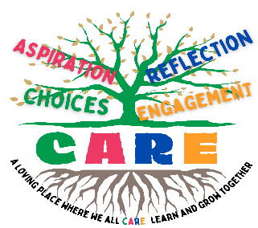
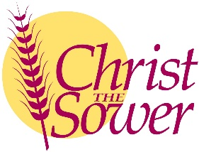
Christ the Sower Ecumenical Primary School
Science Progression of Skills and Knowledge Overview

Evolution
National Curriculum Aims |  | Progression in Skills | Progression in Knowledge
Early learning goal | Children know about similarities and differences in relation to places, objects, materials and living things. They talk about the features of their own immediate environment and how environments might vary from one another. They make observations of animals and plants and explain why some things occur and talk about changes.
Year 1
Year 2
Year 3
Year 4
Year 5
Year 6 | - Recognise that living things have changed over time and that fossils provide information about living things that inhabited the Earth millions of years ago.  - Recognise that living things produce offspring of the same kind, but normally offspring vary and are not identical to their parents.  - Identify how animals and plants are adapted to suit their environment in different ways and that adaptation may lead to evolution. | - Explain that living things have changed over time, using specific examples and evidence.  - Identify that living things produce offspring of the same kind, although the offspring are not identical to either parent.  - Describe how animals and plants can be bred to produce offspring with specific and desired characteristics (selective breeding).  - Identify how animals and plants are adapted to suit their environment, such as giraffes having long necks for feeding, and that adaptations may lead to evolution. | - Scientists compare fossilised remains from the past to living species that exist today to hypothesise how living things have evolved over time.  - Humans and apes share a common ancestry and evidence for this comes from fossil discoveries and genetic comparison.  - Animals that sexually reproduce generate new offspring of the same kind by combining the genetic material of two individuals.  - Each offspring inherits two of every gene, one from the female parent and one from the male parent.  - Animals and plants can be bred to produce offspring with specific and desired characteristics. This is called selective breeding. Examples include cows that produce large quantities of milk or crops that are disease resistant.  - An adaptation is a physical or behavioural trait that allows a living thing to survive and fill an ecological niche.  - Adaptations evolve by natural selection.  - Favourable traits help an organism survive and pass on their genes to subsequent generations.

