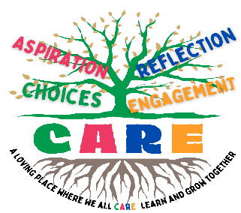
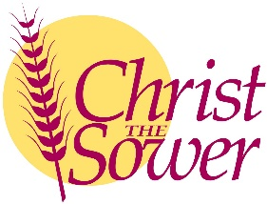
Christ the Sower Ecumenical Primary School
Science Progression of Skills and Knowledge Overview

Earth and Space
National Curriculum Aims |  | Progression in Skills | Progression in Knowledge
Early learning goal | Children know about similarities and differences in relation to places, objects, materials and living things. They talk about the features of their own immediate environment and how environments might vary from one another. They make observations of animals and plants and explain why some things occur and talk about changes.
Year 1
Year 2
Year 3
Year 4
Year 5 | - Describe the movement of the Earth, and other planets, relative to the Sun in the solar system.  - Describe the movement of the Moon relative to the Earth.  - Describe the Sun, Earth and Moon as approximately spherical bodies.  - Use the idea of the Earth’s rotation to explain day and night and the apparent movement of the sun across the sky. | - Describe or model the movement of the planets in our Solar System, including Earth, relative to the Sun.  - Describe or model the movement of the Moon relative to Earth.  - Describe the Sun, Earth and Moon as approximately spherical bodies and use this knowledge to understand the phases of the Moon and eclipses.  - Use the idea of Earth's rotation to explain day and night, and the Sun's apparent movement across the sky. | - The Solar System is made up of the Sun and everything that orbits around it.  - There are eight planets in our Solar System: Mercury, Venus, Earth, Mars, Jupiter, Saturn, Uranus and Neptune.  - Earth orbits around the Sun and a year (365 days) is the length of time it takes for Earth to complete a full orbit.  - The Moon orbits Earth, completing a full orbit every month (28 days).  - The Sun, Earth, Moon and other planets and stars are roughly spherical.  - All planets are spherical because their mass is so large that they have their own force of gravity.  - This force of gravity pulls all of a planet’s material towards its centre, compressing it into the most compact shape – a sphere.  - As Earth orbits the Sun, it also spins on its axis.  - It takes Earth a day (24 hours) to complete a full spin.  - During the day, the Sun appears to move through the sky. However, this is due to the Earth rotating and not the Sun moving.  - Earth rotates to the east or, if viewed from above the North Pole, it rotates anticlockwise, which means the Sun rises in the east and sets in the west.  - As Earth rotates, different parts of it face the Sun, which brings what we call daytime.  - The part facing away is in shadow, which is nighttime.
Year 6

