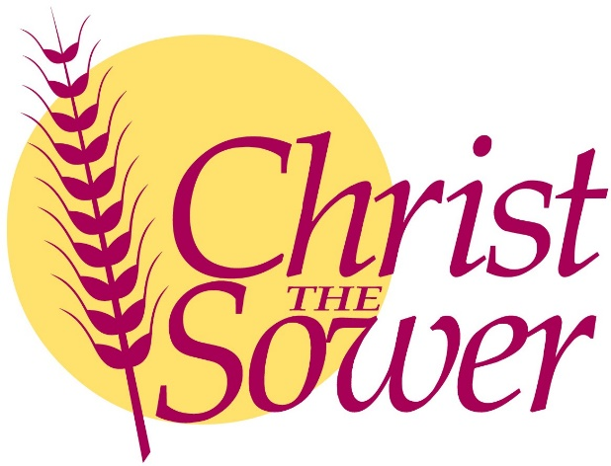

Music Development Plan
2025-2026
At Christ the Sower School Ecumenical School we provide the ‘good earth’ for all our children to flourish, where every child can explore who they are created to be.
Our Christian values ensure that all of our children grow to become the best they can be in a loving place where we all CARE learn and grow together.
Through our CARE Curriculum, we create regular, well-thought-out opportunities which encourage our children to make good choices, appreciate themselves, each other and the world in which they live, reflect on their learning experiences and events and engage with each other, their learning and opportunities.

Our Care Curriculum is designed so that it enables all children to CARE, learning and growing within our Christian community so that they are ready to make a positive contribution to the wider world and are fully prepared for the next stage of their education and development.

Overview
Detail | Information
Academic year that this summary covers | 2025 – 2026
Date this summary was published | September 2025
Date this summary will be reviewed | September 2026
Name of the school music lead | Miss Mel Nugent
Name of school leadership team member with responsibility for music (if different)
Name of local music hub | Milton Keynes Music Service
Name of other music education organisation(s) (if partnership in place) | RockSteady

This is a summary of how our school delivers music education to all our pupils across three areas – curriculum music, co-curricular provision and musical experiences – and what changes we are planning in future years. This information is to help pupils and parents or carers understand what our school offers and who we work with to support our pupils’ music education.

Part A: Curriculum music
This is about what we teach in lesson time, how much time is spent teaching music and any music qualifications or awards that pupils can achieve.
At Christ the Sower, all children participate in a weekly hour-long music lesson during the second half of each term. These lessons are taught by the class teacher, with support where needed from the Music Curriculum Lead. The curriculum is moulded around the use of Charanga and follows the national plan for music education as set out in the model music curriculum. A broad and varied range of music is taught covering a wide range of cultures and genres from around the world, starting in EYFS and continuing in Key Stage 1 and Key Stage 2. This has been specifically created to suit the needs of our children at Christ the Sower whose backgrounds are also culturally diverse.
Y6 children have a whole half term dedicated to women in music and the use of music technology, helping them to gain the necessary skills to prepare them for music at Key Stage 3.
Our music curriculum supports the development of children in their singing, listening, composing and performing. At the end of each unit, classes are encouraged to perform their final piece to another class, parent visitors or during assembly, allowing them the opportunity to express themselves and show development. During the half term where music is taught, lessons are 1 hour long. We also have weekly 20-minute singing assemblies across the year, including numerous performance opportunities where children continue to develop their musical skills.
All music lessons take into consideration a range of skill levels, including children with SEND. Accessible materials and instruments are provided where necessary.

Part B: Music tuition, choirs and ensembles.
This is about opportunities for pupils to sing and play music, outside of lesson time, including choirs, ensembles and bands, and how pupils can make progress in music beyond the core curriculum.
Alongside the ongoing weekly whole class music lessons, we also offer optional instrumental lessons in piano, guitar and violin with a specialist music teacher weekly. These lessons are offered on a 1-1, paired or small group basis. Our music tutors are provided by Milton Keynes Music Service.
The lessons are paid for by parents and carers; however, we offer subsidised funding for any child with Pupil Premium. Instruments for these sessions are owned by the school and are loaned directly to the parents for free.
We have a KS2 choir which is organised every year to support our yearly Christmas carol concert. These sessions run for 1 hour per week between October half term and Christmas, with additional practise held during singing assemblies with the rest of the school.
There is also a weekly singing choir which currently includes 50 children from across years 4, 5 and 6. Children are introduced to a range of modern and traditional music which they are then invited to perform in a stadium as part of the Young Voices Choir alongside 10,000 other children from across the country. We have previously attended concerts in London and Birmingham.
In addition to this, we also offer the opportunity for children to join our school bands, run by Rock Steady. Rehearsals run for 20 minutes per week and children then perform their completed song at the end of each term during an assembly. These places are paid for by parents and carers, though we do support at least one child per term to attend as part of Rock Steady’s match funding scheme.

Part C: Musical experiences
This is about all the other musical events and opportunities that we organise, such as singing in assembly, concerts and shows, and trips to professional concerts.
Music experiences are integral to life at Christ the Sower and as so, we offer regular performance opportunities in a range of venues and events.
In the Autumn Term, KS1 and EYFS hold their year nativity, which is supported by song. Each phase learns a range of songs to accompany their nativity story which is them performed to the whole school and parents during afters-school shows. The PTA sells refreshments during this event as a fundraiser for the school.
At the end of the Autumn term, we also have our yearly Christmas carol concert. This event is organised and run by our Music Curriculum Lead and involves children learning a range of Christmas carols to sing as a choir, as well as children organising their own bands, singing and dance troupes to perform to parents. This event is held on the playground after school due to the size of the event and includes the use of professional amplifying equipment and stage lighting. The PTA also uses this opportunity to fundraise through refreshment sales.

During the spring term our school choir from years 4, 5 and 6 make the trip to their Young Voices concert in either the London O2 or Birmingham’s NEC arenas. This is a full day event including chances to sing as part of a 10,000 strong choir, perform to parents in an arena and sing alongside celebrities and a full orchestra, with guidance from a professional music conductor. This club is initially free for children to join, with parents later supporting with payments for coaches and personalised t-shirts. This can be supported through our PP funding as needed, assessed on an individual basis.
In addition to this, we also offer the opportunity for children to join our school bands, run by Rock Steady. Rehearsals run for 20 minutes per week and children then perform their completed song at the end of each term during an assembly. These places are paid for by parents and carers, though we do support at least one child per term to attend as part of Rock Steady’s match funding scheme.
In the Summer term we hold our KS2 end-of-year production. This is a full-scale event with costumes, songs, dances and a range of solo and group opportunities. Children are able to audition for roles during the second half of the spring term, with weekly rehearsals moving throughout the remainder of the year. These productions are performed to the whole school and to parents in a ticketed after-school event. This is supported by our PTA who use this opportunity to offer refreshments as school fundraising.

In the future
This is about what the school is planning for subsequent years.
Our plan is to:
- Re-create the school song used when Christ the Sower was first established in 2004 using support from the Rock Steady band leaders to perform and record a digital version. This will allow us to celebrate our 20-year anniversary and reestablish tradition and our values as a faith school.
- Organise formal performance opportunities for every year group across 2025-2026.
- Introduce a ‘Music Day’ at the end of the school year, allowing every year group the chance to reflect on their learning and progression as well as offer additional performance opportunities.
- Seek out opportunities for the choir to perform in the community.
- Seek opportunities for the children to be exposed to musical experiences and performances across the school year.

Further information (optional)
Specialist music instrument tuition is offered through Milton Keynes Music Service. The tutors strongly encourage children to join the hub’s various ensembles and courses when children reach the appropriate level. This is the link to the Milton Keynes Music Service Website: https://miltonkeynesmusicservice.com/
This is the website link for Rocksteady, where children are able to sign up to join an age-appropriate band led by a professional band leader. Additional information including how to sign up can be found here. https://www.rocksteadymusicschool.com/

