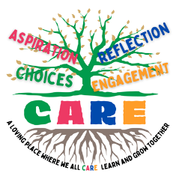
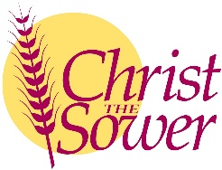
CARE Curriculum
Knowledge and Skills Progression Document
Physical Development
 | Expectations for Nursery |  |  |  |  |  |  |  | Expectations for Reception |  |  |  |  |  |  | Links to KS1
Scissors (DT Link) | Shows preference for a dominant hand |  | Use one handed tool |  |  | Controlled actions when using one handed tools |  |  |  |  |  |  |  |  |  | Select from and use a range of tools and equipment to perform practical tasks  (for example, cutting, shaping, joining and finishing)
Scissors (DT Link) | Hold scissors appropriately |  |  |  | Open and close scissors |  |  | Holds paper and makes cuts
Scissors (DT Link) | Makes snips in paper |  |  |  |  |  | Cuts in a straight line |  | Cuts out simple shapes |  |  | Cuts along curved lines |  | Cuts out complicated shapes
Gross Motor (PE Link) | Go up stairs |  |  | Climb on apparatus |  |  | Uses a range of apparatus |  |  |  |  | Negotiate space and obstacles |  |  |  | Master basic movements including running, jumping, throwing and catching, as well as developing balance, agility and co-ordination, and begin to apply these in a range of activities
Gross Motor (PE Link) | Develop core strength |  |  | Hop, skip, stand on one leg |  |  | Revise and refine fundamental movement skills |  |  | Develops body strength |  |  |  | Move energetically
Gross Motor (PE Link) | Develop ball skills |  |  | Throw, catch, kick a large ball |  |  | Revise and refine fundamental ball skills |  |  | Throw, catch, kick, pass, bat, aim with a ball
Gross Motor (PE Link) | Rides on larger bikes, trikes and scooters |  |  |  |  |  | Develops coordination and control when using equipment |  |  |  |  |  |  | Balance Bikes
Gross Motor (PE Link) | Uses muscle movements to wave objects |  |  | Remember sequences and patterns of movement |  |  | Develops fluency when moving |  |  |  |  | Combines movements |  | Demonstrates strength, balance and coordination
Fine Motor | Can use two hands together e.g. open jars |  |  | Uses dominant hand and an assist hand during activities |  |  | Control and manipulate small tools |  |  |  |  | Tripod grasp for tasks and manipulating objects |  | Gets faster at tasks |  | Handwriting
Writing | Scribbles randomly on paper | Scribbles spontaneously in different directions |  |  | Copies simple shapes |  | Imitates shapes that involve multiple movement |  | Accuracy and care when drawing |  | Copies letters |  | Forms most letters correctly |  | Holds pencil effectively - Tripod grip for writing | Pupils should be able to form letters correctly and confidently.

