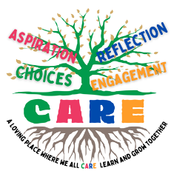
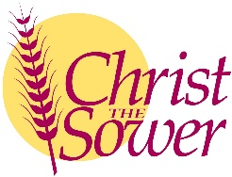
CARE Curriculum
Knowledge and Skills Progression Document
Literacy
 | Expectations for Nursery |  |  |  |  |  |  | Expectations for Reception |  |  |  |  |  |  |  | Links to KS1
Comprehension – Exploring Books | Explores familiar stories with an adult | Handles books carefully |  | Explore books independently |  |  | Understands print carries meaning and is read from left to right |  |  |  |  | Talks about texts they have shared |  | Rereads favourite texts |  | Re-read books to build up fluency and confidence.
Comprehension – Exploring Books | Talks about illustrations in stories |  |  | Uses pictures to describe main events |  |  |  |  |  |  |  | Retell stories in their own words without picture prompts |  |  |  | Becoming increasingly familiar with and retelling a wider range of stories, fairy stories and traditional tales
Comprehension – Exploring Books | Engages in conversations about familiar stories |  |  |  | Learns new vocabulary from books |  |  |  | Discussion of different texts |  |  | Understanding of narratives |  | Reading for meaning |  | Participate in discussion about what is read to them, taking turns and listening to what others say.
Word Reading | Enjoys listening to songs and rhymes |  | Joins in with rhymes |  | Identifies rhymes in books and poems |  |  |  |  |  |  | Can suggest a rhyming word |  |  |  | Learning to appreciate rhymes and poems, and to recite some by heart
Word Reading | Hears initial sounds in words |  | Matching words by their initial sound |  | Reads letter sounds |  |  |  | Blend sounds when reading |  |  | Building sight vocabulary of tricky words |  | Reading simple sentences |  | Read aloud accurately books that are consistent with their developing phonic knowledge.
Writing | Gross Motor | Developing fine motor control |  | Pre-handwriting shapes |  | Pictures |  | Copying letters |  |  | Initial sounds |  | Labels, captions |  | Writing sentences | Pupils should understand, through demonstration, the skills and processes essential to writing: that is, thinking aloud as they collect ideas, drafting, and re-reading to check their meaning is clear
Writing | Recognises their name | Writes some of the letters in their name |  | Writes name with appropriate letter formation |  |  |  |  |  | Forms lower- and upper-case letters |  |  |  |  |  | Taught to write with a joined style as soon as they can form letters securely with the correct orientation.
Writing | Mark-making |  |  | Understand writing carries meaning |  |  |  | Segments words when writing |  |  |  |  | Checks writing to ensure it makes sense |  |  | Make simple additions, revisions and corrections to their own writing
Independence | Uses simple mark-making tools |  |  | Marks indepdently and explains what they are writing |  |  |  | Writing to meaning |  |  |  |  | Writing for different purposes: lists, posters, stories, labels |  |  | Writing narratives about personal experiences and those of others (real and fictional)  Writing about real event  Writing poetry  Writing for different purposes

