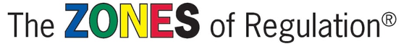
Introducing….
… at CtS.
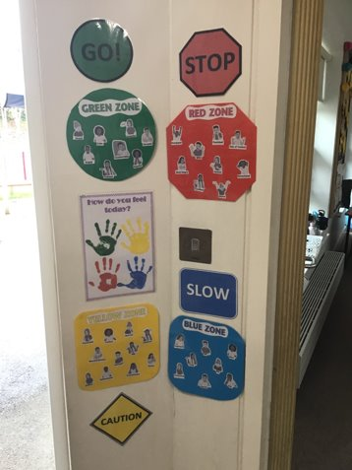
We recognise the importance of promoting positive mental health and emotional wellbeing to our children and their families. By implementing the Zones of Regulation, we aim to teach our children to identify emotions in themselves and others and provide them with a bank of strategies to help regulate their emotions and improve their wellbeing.
From time to time, all of us find it hard to manage strong feelings such as worry, anger, fear or tiredness, and this stops us getting on with our day effectively.
Children who feel these emotions often find it hard to learn and concentrate in school. We want to help them to tackle learning challenges and build better resilience, so they don’t give up so easily when faced with difficulty.
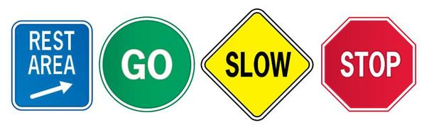

We have introduced across the school.
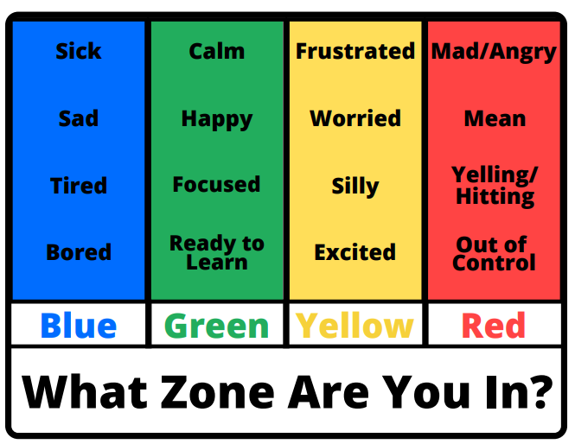
How it works
There are four coloured zones that help a child to identify how the body feels and the emotions experienced.

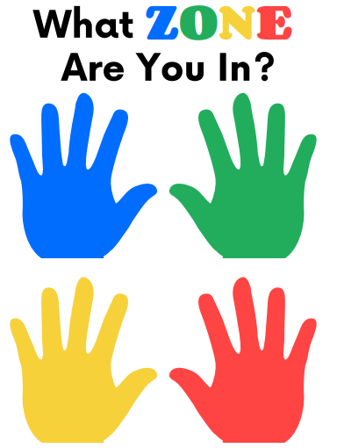
Children are encouraged to develop their own toolkit. Considering questions such as:

What helps you to calm down when you are stressed? e.g. squeeze a fidget ball.

What helps you to focus when you are tired?
e.g. go for a brisk walk.

What do you do to calm down when you are angry? e.g. try some breathing exercises.
We will all experience all zones and there are no good or bad zones. However, our success in regulating our emotions depends on us recognising our emotion, understanding it and putting a support strategy in place.

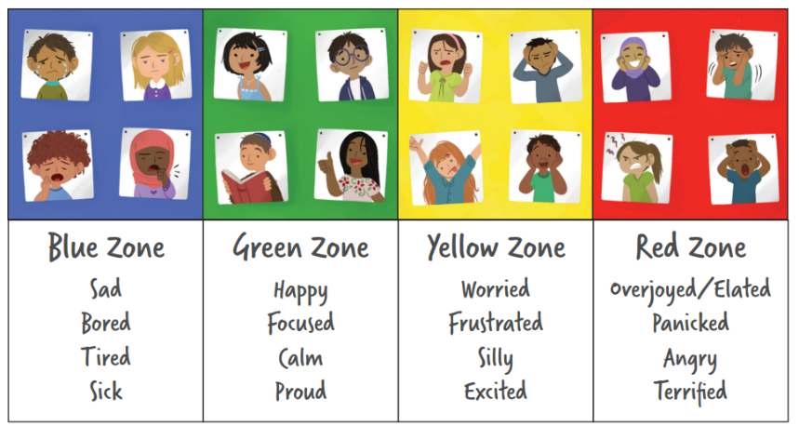
Additionally, the Zones of Regulation helps children to recognise their own triggers, learn to read facial expressions, develop problem-solving skills, and become more attuned to how their actions affect other people.

Tips for parents

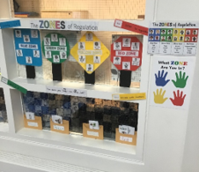
- Identify your own feelings using Zones language. e.g. This is really frustrating me, I think I am in the Yellow Zone. I need to use a tool to calm down. I will take some deep breaths.

- At times, wonder which zone your child is in. Or a character in a film or book. e.g. You look sleepy. Are you in the blue zone?

- Show interest in learning about your child’s triggers and Zones tools.

- Share with the child how his or her behaviour is affecting the zone you are in and how you feel.

- Remember we are all unique and the strategies that work for one person might not help another.

