

Christ the Sower Ecumenical Primary School Pupil Premium Strategy Statement:

Autumn 2022 Review for the Academic year 2021-2022
Overview: This report is based on 93 PP children in our school in the school year of 2021-2022. We have a total of 12 children in our Nursery and Reception. The data outlined below considers 81 of our Pupil Premium children from Y1 to Y6; 30 of whom are on the SEND register, 25 EAL and 2 children with an EHCP. Since the start of the academic year, 23 new children were added to the register. This was the first full year of school since the disruption of the pandemic. It is important to note that the disruption in the second half of the Autumn term with staff illnesses had a huge impact on the consistency of teaching thus progress and attainment were affected. QFT, same day interventions and afternoon targeted interventions did not take place fully to plug the gaps as identified. The only key interventions that took place were for those children with IPMs (Individual Provision Maps).
Throughout the academic year, staff continued to ensure QFT in the first instance and ‘hotmarking’ in daily lessons, with scaffolding where necessary to support identified children. As per the PP action plan, PP was a standing agenda item during staff and team meetings- all staff continued to raise the profile of PP children through enrichment opportunities, roles within class, sports and school council.
Targeted Tuition was successfully implemented to support key children in Year 5 and Year 6 for Reading and Maths. The impact of this is reflected in the data set below.
The take up of enrichment activities continued to steadily increase throughout the year. The number of children taking peripatetic lessons rose from 5 to 12 children in the year. The number of children taking part in clubs and after school activities was consistent each term:
Autumn term | Spring term | Summer term
33/71= 46% | 32/72= 45% | 34/79= 43%*
*It is important to note that in the Summer term, leading upto SATs, the Year 6 PP children attended revision sessions instead of clubs. The children resumed their club participation after the tests.

School overview
Detail | Data
School name | Christ the Sower Ecumenical Primary School
Number of pupils in school | 338
Proportion (%) of pupil premium eligible pupils | 27.22%
Academic year/years that our current pupil premium strategy plan covers | 2 years  2021-2023
Date this statement was published | November 2021
Date on which it will be reviewed | November 2023
Statement authorised by | Mel Nugent
Pupil premium lead | Saeeda Wilson-Andoh
Governor / Trustee lead | Mike Morris
Funding overview
Detail | Amount
Pupil premium funding allocation this academic year  We received £17,480 in July. | £69,940
Recovery premium funding allocation this academic year  Figure shown is the calculation based on the October’20 census- 52 Ever6FSM x £145 | £ 7,540
Pupil premium funding carried forward from previous years (enter £0 if not applicable) | £ 0
Total budget for this academic year (projected) | £ 77,480

Targeted spend | Budgeted cost | Spend to date | Impact of spending to date
Teaching: CPD | £4,000 | £1,525 | 33% of our PP children are also on the SEN register with very low starting points. Part of this budget has supported us to pay towards the SENCO’s SEN qualification, which is aimed at equipping us with practical tools and knowledge we need to increase the participation of our learners with SEND needs. It has also supported the purchase of Power Maths textbooks to support small groups of children who are working on different class books.  Number Sense in KS1- improved number recognition for KS1 children and improved teacher subject knowledge in teaching for Maths mastery.  Enigma Maths Mastery- improved pedagogical knowledge of teaching for mastery in KS2. Maths observations demonstrates strong application of teaching for mastery in 7 out of 8 classes.  Reading-whole school training on teaching phonics across the school has continued to support small groups phonic intervention and the purchasing of specific resources to support teaching. All children have been baselined and their progress will continue to be monitored termly.
Quality first teaching support for all teachers  Whole school Power Maths scheme for delivery of Maths  Maths and English are high priority on school development plan and CPD plan  Pupil Progress meetings track progress of PP pupils and appropriate, timely interventions are put in place. | £43,000 | £42,288 | Continued CPD across the subjects has helped to ensure that our teachers have improved subject knowledge to ensure consistency in teaching approaches.  High level vocabulary is evident in all classrooms and its application can be seen in children’s books. Scaffolding, hotmarking (live marking) and same day interventions are consistently supporting the learning process on a daily basis.  In Maths, Enigma Maths Hub supported our teachers in breaking down learning into smaller steps for our children to cement understanding of teaching for mastery.  PP children who are working significantly below ARE are taught in small groups to help close the gap.  Pupil Progress meeting show that a high percentage of PP children continue to make progress in line or better than their peers.  Targeted intervention  Lexia (14 children across Year 4 to Year 6), Reading Eggs (4 children in Year 4), Phonics club (9 children across Year 1 and Year 2) all had a measurable impact as can be seen in the data below.  Attainment data for the academic year 2021-2022 across the school:  It is very positive to see that more PP children were attaining in Maths compared to whole school and comparably similar in Reading. It is also very pleasing to see that there are now more PP children working above the expected standard, although the numbers are small, it is still significant because it demonstrates our continued strive for high quality teaching for all, thus allowing those with the ability to work above, the chance to excel.  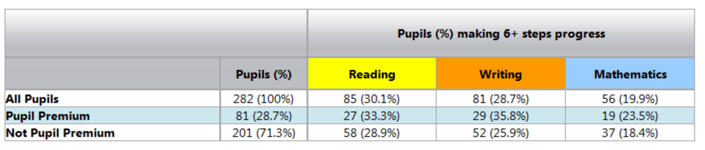  Progress data for Autumn 1 (2021) to Summer 2 (2022) across the school:  Pupil Premium children made more progress in Reading, Writing and Maths in comparison to the whole school and non-PP.  It is important to note that the progress data compares data for the whole of the year because a number of PP children joined the school in the Autumn term so comparison could not be made to the previous term.  This good progress data continues to affirm our understanding of our PP children and their starting points. At CtS, we know our children and we tailor the learning to meet their needs.  Whole school 2022 KS1 and KS2 National Progress and Attainment data  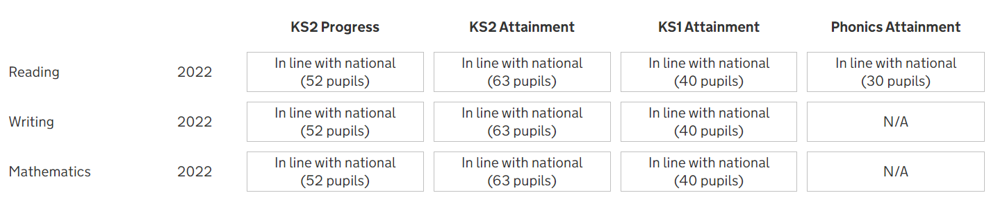    As you can see there is no national data which highlights the Pupil Premium data but it is pleasing to see that our whole school data is inline with national. This again affirms that our provision for our Pupil Premium children is good.
  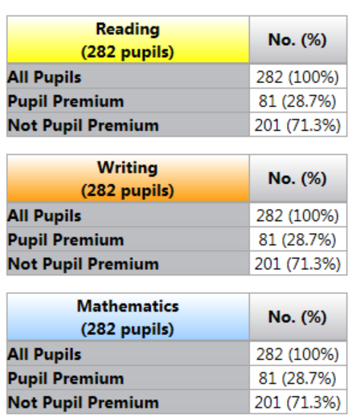 | 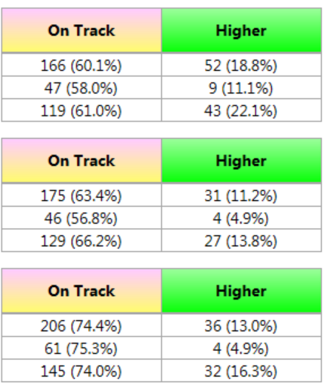
CPD opportunities for teachers to raise pupil outcomes:  - Enigma Maths Mastery- Developing for Mastery  - Mastering Number Programme  - WRInc Phonics and its resources | £43,000 | £42,288
TAs deliver same day interventions to iron out misconceptions | £43,000 | £42,288
T/TAs to deliver weekly small group interventions to pupils identified as in need using Recovery funding | £7,540 | £5,616 | All targeted children have received their intervention as identified using the Recovery funding.  Pupil voice shows that pupils are more confident and can better articulate their answers and reasoning in whole class lessons.  A teacher was employed to teach Reading and Maths to targeted children using the Recovery funding. Seven PP children were targeted for Reading using the Recovery funding and five of them met the expected standard. In maths, although only four out of the eleven PP children targeted met the expected standard, the rest scored 99 as a scaled score, 1 off the expected scaled score of 100.
Inclusion lead to support the well-being of parents and children  - PP pupils attendance is closely monitored, pupils below 96% are identified and protocols followed.  - Inclusion lead phones families at 9am if pupil not in school and offers support.  - Inclusion and another member of staff will pick up child from home if required. | £30,000 | £10,000 | Well-being and inclusion lead has worked tirelessly with children and key families to ensure consistent attendance.  Termly attendance monitoring continues to be monitored and letters sent out as necessary to those families whose children’s attendance is a cause for concern.  Well-being and PP lead continue to hold attendance meetings with key families and offer support.  13 families so far this year have been supported in more detail with early help, social housing, school nurse referrals and we continues to work with the Virtual schools to ensure compliance with LAC provision.  % of attendance:  Attendance is broadly inline with whole school. We continue to monitor termly and offer support where necessary.  Example of attendance monitoring:  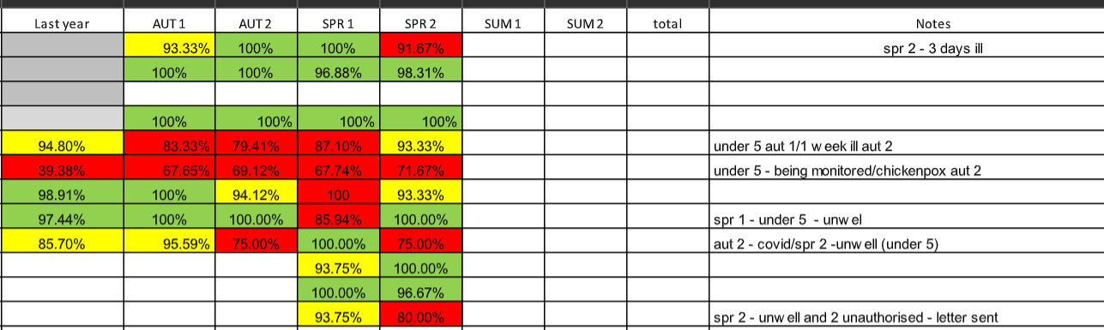
   | Whole school | PP attendance | Non-PP
  2021-2022 | 93.7% | 91.7% | 94.4%
Cultural capital experiences promoted in our book-led curriculum.  Reduction in cost of trips and residential trips for PP  Every PP child is entitled to a free sport event each term and participation is highly encouraged  Support with uniforms, breakfast/after school provision and peripatetic lessons | £30,000 | £6,283 | Targeted texts are carefully chosen to support the richness of language in the classroom. All PP children are encouraged to borrow books from our school library. PP children working below ARE in Reading are read with atleast x3 times in a week, with some children daily. WRInc phonics and its associated reading books are specifically matched to the child’s reading level and these are assessed termly.  PP children continue to participate in atleast one free club. The children eligible for clubs is consistent on a termly basis. See below for a termly breakdown with children from Year 1 to Year 6:  *It is important to note that in the Summer term, leading upto SATs, the Year 6 PP children attended revision sessions instead of clubs. This uptake increased after the tests.  12 children continue to take up peripatetic lessons, an increase from 5 since last academic year.  All PP children were supported with trips across the year: children in Y1 and Y2 went to the zoo trip, swimming lessons were paid for children in Y4, children in Y6 were able to take part in their Parks Trust trip to support their learning.  We continue to work with families for before and after school provision, with some parents paying a percentage of the fee towards it. Where a parent cannot support towards the fee, a short term support is put in place after discussion with parents.
  Autumn term | Spring term | Summer term
  33/71= 46% | 32/72= 45% | 34/79= 43%

Total budget spend to date: £65,712

