
Christ the Sower Ecumenical Primary School Pupil Premium Strategy Statement

This statement details our school’s use of pupil premium (and recovery premium) funding to help improve the attainment of our disadvantaged pupils.

It outlines our pupil premium strategy, how we intend to spend the funding in the next two academic years and the effect that last year’s spending of pupil premium had within our school.

School overview
Detail | Data
Number of pupils in school | 206
Proportion (%) of pupil premium eligible pupils | 31% (63)
Academic year/years that our current pupil premium strategy plan covers (3year plans are recommended) | 2023-2024 to 2025/2026
Date this statement was published | December 2023  December 2024  December 2025
Date on which it will be reviewed | July 2024  July 2025  Next review: July 2026
Statement authorised by | Mel Nugent
Pupil premium lead | Saeeda Wilson-Andoh
Governor / Trustee lead | Michael Morris/ Michael Mill
Funding overview
Detail | Amount
Pupil premium funding allocation this academic year  (This is based on the last census of October 2024) | £90,900
Pupil premium funding carried forward from previous years (enter £0 if not applicable) | £ 0
Total budget for this academic year (projected) | £90,900

Part A: Pupil premium strategy plan

Statement of intent
At Christ the Sower, we aim to provide the ‘good earth’ for all our pupil premium children by ensuring that the quality of teaching across the school continues to be good with increasing areas of outstanding teaching. The needs of PP pupils are core to the work that we do, with a consistent approach and adaptive teaching, where necessary, across the school. Using recent research, we aim for high quality CPD delivered to all staff, including that which has a focus on the needs of more deprived children.
Our aim is that all our Pupil Premium children make accelerated progress in core subjects so that their attainment shifts closer to that of their peers. We use same-day opportunities to close daily gaps in lessons. We ensure that every pupil is given opportunities to participate in wider enrichment strategies to improve not only their attendance, confidence and readiness to learn but also their well-being.
We believe that pupil premium should be used to impact the wider school but it is also crucial that the pupil premium is specifically tailored to meet the needs of individual pupils, in addition to, and in different ways from our other intervention programmes. We offer some Pupil Premium children a more personalised support that goes beyond our provision for academic development. We know that sometimes life can be harder for children and their families in receipt of the Pupil Premium so our Pupil Premium lead and Inclusion Lead works tirelessly with parents to ensure that any difficulties can be addressed, and we are able to sign post parents to other forms of support for children and for families.
We continue to ensure that Christ the Sower continues to be ‘A loving place where we all care, learn and grow together.

Challenges

This details the key challenges to achievement that we have identified among our disadvantaged pupils.
Challenge number | Detail of challenge
1 | Vocabulary gaps  Assessments and pupil voice shows vocabulary gaps amongst our pupils. There is a significant gap amongst our disadvantaged children.
2 | Outcomes in core subjects  Internal assessments, in school pupil progress meetings with teachers and discussions with pupils highlights that disadvantaged children have lower starting points, make less progress and do not attain as well in comparison to their non-disadvantaged peers.
3 | Intervention  Discussions with staff shows that disadvantaged children need targeted intervention (1:1, small group, pre- teach) outside of QFT to help close the gap.
4 | Enrichment and extended opportunities  Attendance data for our extended enrichment over the last year has shown lower attendance and uptake in comparison to non- disadvantaged pupils.
5 | Low parental engagement  Discussion with our stakeholders shows that lack of parental engagement amongst our disadvantaged is having an impact on their progress, attainment and wider school experiences.

Intended outcomes
This explains the outcomes we are aiming for by the end of our current strategy plan, and how we will measure whether they have been achieved.
Intended outcome | Success criteria
Improved vocabulary amongst disadvantaged pupils. | Assessments using our 360 approach (pupil voice, book looks, observations) will show a significant improvement in pupils understanding and use of vocabulary (context- specific and Tier 2 vocabulary) in their oral language and in their writing across the curriculum.
Improved attainment in reading, writing and maths for our disadvantaged pupils.  An increased number to meet the Multiplication Timetables Check at the end of Year 4 | KS2 outcomes in 2025/2026 for reading and maths will show that disadvantaged pupil outcomes are in line with their non-disadvantaged peers.  KS2 teacher assessment in in 2025/2026 for writing show that disadvantaged pupils meet the expected standard in line with their peers.  KS2 maths, reading and writing outcomes in 2025/2026 outcomes will show an increased number of disadvantaged children working at the greater depth standard in line with their peers.  Over 70% of disadvantaged children in Year 4 to meet the MTC at the end of Y4
To offer bespoke intervention to close the learning gap for all pupils, particularly our disadvantaged pupils. | Through pupil and staff voice, pupil progress meetings, observations and book look, all pupils are making progress in their reading, writing and maths skills and applying them more confidently, with disadvantaged pupils making more than expected progress.
An increased uptake and improved attendance in enrichment and extended opportunities amongst our disadvantaged pupils. | Pupil voice shows an improved attendance and self-esteem in taking part in extended opportunities.  There is a strategic plan for enabling disadvantaged children to partake in enrichment and extended opportunities:  - All PP children to be spoken to before club letters go out to whole school. Each PP child is given 1 free club which is paid for by the school. Participation is sustained throughout the year.  - Support for paying for musical instrument hire and lessons.  - PP children to be given opportunities to represent their school in festivals and competitions.  - PP children to be selected to showcase their musical ability in assemblies once a term.  - Visitors from various industries and within the community to be invited to school to share their jobs and life experiences.  - All PP children to have the opportunity to attend trips and residential opportunities through subsidies and discount where necessary.  Support with breakfast clubs for all PP children to be in school on time.
Improved parental engagement amongst our disadvantaged pupils | There is an improved parental participation as shown by:  - 90% parental attendance at parents consultation evenings  - An increased number of PP parents in attendance in each class for Publishing Parties each term.  - An increased attendance of PP parents to aspirational events each term.  - One drop in session for parents each term.

Activity in this academic year
This details how we intend to spend our pupil premium (and recovery premium funding) this academic year to address the challenges listed above.

Teaching (for example, CPD, recruitment and retention)
Budgeted cost: £20,900
Activity | Evidence that supports this approach | Challenge number(s) addressed
CPD for teachers and support staff on the teaching of vocabulary and how to monitor this in class for all pupils with a focus on disadvantaged pupils. | EEF guide to pupil premium shows that oral language approaches which explicitly extends pupils’ spoken vocabulary adds 6 months of impact to pupil learning.  Oral language interventions | EEF (educationendowmentfoundation.org.uk) | 1, 2, 3
Whole school CPD in making assessments for learning and making judgments as part of formative and summative assessments. | Providing feedback is a well-evidenced to have a high impact on learning outcomes. Effective feedback tends to focus on the task, subject and self-regulation strategies: it provides specific information on how to improve.  The EEF Guide to the Pupil Premium | EEF (educationendowmentfoundation.org.uk) | 1, 2, 3
Continued Phonics coaching for staff using high quality resources (including books) to secure stronger phonics teaching for all pupils but especially those who are disadvantaged. | Phonics approaches have a strong evidence base that indicates a positive impact on the accuracy of word reading (though not necessarily comprehension), particularly for disadvantaged pupils:  Feedback | EEF (educationendowmentfoundation.org.uk) | 2,3
Whole school CPD and refresher training for Zones of Regulation. SENCO to support teachers to model and embed Zones of Regulation strategies and language.  External CPD training to support a change in behaviour culture of key disadvantaged children around school and improve their learning experience. | EEF research shows that Social and emotional learning (SEL) support improves children’s outcomes at school and later in life ( (e.g., improved academic performance, attitudes, behaviour and relationships with peers) | 2,3

Targeted academic support (for example, tutoring, one-to-one support, structured interventions)
Budgeted cost: £30,000
Activity | Evidence that supports this approach | Challenge number(s) addressed
School Led Tutoring  To provide a blend of tuition, mentoring and school-led tutoring for pupils who have fallen below, including those who are high attainers. | One to one tuition is very effective at providing targeted support for pupils that are identified as having low prior attainment or are struggling in particular areas. Tuition is more likely to impact if it is additional to and explicitly linked with normal lessons.  One to one tuition | EEF (educationendowmentfoundation.org.uk) | 1, 2, 3
CPD opportunities for identified teaching assistants to raise pupil outcomes:  - WRInc Phonics coaching | Research shows that interventions which are based on a clearly specified approach which staff have been trained to deliver has a positive benefit pupil’s progress and attainment:  Teaching Assistant Interventions | EEF (educationendowmentfoundation.org.uk) | 2, 3
TAs deliver same day interventions to iron out misconceptions  T/TAs to deliver weekly small group interventions to pupils identified as in need using Recovery funding. | Small group support can be effectively targeted at pupils from disadvantaged backgrounds. It adds an additional four months progress over the course of a year.  Small group tuition | EEF (educationendowmentfoundation.org.uk) | 3, 4, 5

Wider strategies (for example, trips, related to attendance, behaviour, wellbeing)
Budgeted cost: £ 40,000
Activity | Evidence that supports this approach | Challenge number(s) addressed
Inclusion lead to support the well-being of parents and children  - PP pupils attendance is closely monitored, pupils below 96% are identified and protocols followed.  - Inclusion lead phones families at 9am if pupil not in school and offers support.  - Inclusion and another member of staff will pick up child from home if required. | EEF toolkit– Parental engagement  Decrease in numbers of families in CIN, CP due to increase in families accessing early intervention from Inclusion lead.  A dedicated person in the role, who builds a relationship where the parents trust them and feels they will listen to them and provides them with the support they require, leads to improved relationships with school and home lives for the whole family.  Dedicated person who monitors attendance and who has a good relationship with parents is most effective at ensuring good pupil attendance.  Parental engagement | EEF (educationendowmentfoundation.org.uk) | 2, 4
- Cultural capital experiences promoted in the wider curriculum.  - Reduction in cost of trips and residential trips for PP  - Every PP child is entitled to a free sports/club event each term and participation is highly encouraged  - Support with uniforms, breakfast/after school provision and peripatetic lessons  - Free School Meals provision for all disadvantaged pupils. | Learning is contextualised in concrete experiences and language rich environments. Children see themselves in the carefully selected texts that includes and celebrates the culturally diverse backgrounds of our children and school community  Pupil surveys reflect greater enjoyment and engagement in school in lessons.  Enrichment activities such as arts participation have shown improved outcome in English, maths, and science.  Arts participation | EEF (educationendowmentfoundation.org.uk)  EEF – By providing physical activities free of charge, schools give pupils access to benefits and opportunities that might not otherwise be available to them.  Physical activity | EEF (educationendowmentfoundation.org.uk) | 1, 2, 4

Total budgeted cost: £90,900

Part B: Review of outcomes in the previous academic year

Pupil premium strategy outcomes
Review of 2024-2025 academic year.
We have analysed the performance of our disadvantaged children using our internal assessments as well as all statutory assessment outcomes data during 2024-25.

Christ the Sower School Primary - Statutory Assessments Outcomes 2025
Early Years Foundation Stage EYFSP GLD
All | PP
88% (22/25) | 78% (7/9)

Additional context: Both children are on the SEN register: one who is EAL and has language and communication need and the other child is on a part time timetable.

Phonics Screening
Year 1 All | Year 1 PP | Year 2 All (including those who passed in Year 1) | Year 2 PP (including those who passed in Year 1)
85%  (23/27) | 70%  (7/10) | 87%  (27/31 including 2x Nest children) | 70%  (7/10 – including 2x Nest children)

Year 1 additional context- out of the 3 children who did not meet the check, 1 child was new to us in the Summer term with very low starting points and on the SEN register for communication and language needs. One other child has just started to confidently read up to diagraph sounds.
Year 2 additional context – 2 children in Year 2 did not sit the phonics screening check in Year 1 or in the recheck in Year 2. This is due to them having significant needs, global delay and being nonverbal. The other child, although she had made significant progress through out the year with her reading, was just shy of meeting the check.

End of Key Stage 2 Outcomes
 | Reading |  | Writing |  | Maths |  | Combined
 | EXS+ | GDS | EXS+ | GDS | EXS+ | GDS | EXS+ | GDS
CTS ALL | 82% | 24% | 85% | 27% | 76% | 33% | 67% | 15%
PP | 69% | 6% | 75% | 25% | 57% | 19% | 44% | 0%
Multiplication Check
Average Score | ALL | PP | SEN
Number of pupils who achieved 21 marks or greater | (29/32)  91% | 5/6  83% | 3/5  60%

Internal Assessments
When tracking internal assessments, there is a focus on the progress of pupils throughout the key points in the academic year. There is a strong emphasis on book scrutiny, pupil voice, as well as teacher administered tests and discussions with teachers during pupil progress meetings to give us a 360 approach to individual children and their progress. We compare and track progress and attainment termly as well as at the beginning of the year and compare this to the end of the year and discuss targeted interventions as necessary.

The table for each year group demonstrates the attainment data in comparison to baseline at the beginning of the year.

Year 1
Progress: In year 1, the Autumn data is based on 22 children, 1PP child who was working towards GDS left at the end of Summer 1. The class increased to 27; out of the 5 new children, 2 were PP with low starting points- this had an impact on the overall progress measure of the cohort.

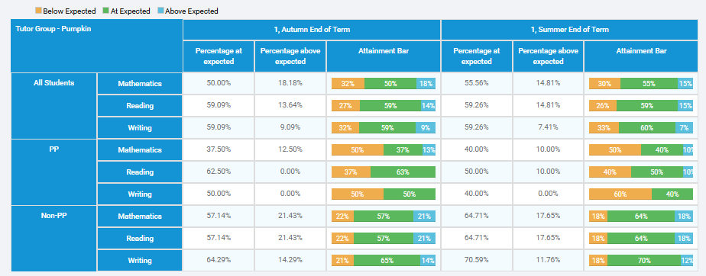

Year 2
Progress: In year 2, in reading and maths, there has been a reduction in children working below ARE and consistent progress in pupils working at GDS. Children here have made accelerated progress in Maths with 80% now working at ARE+. It is important to note that this data, is significantly impacted by two children with global delay and both have an EHCP; their provision is carefully planned and adapted to meet their needs which is mostly outside of the cohort.

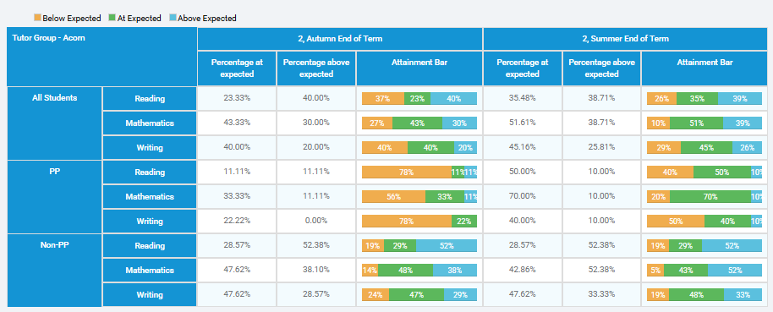

Year 3
Progress: In year 3, in all three core subjects, there has been a reduction in children working below ARE and a consistent progress for those working at GDS. Children in this class have the highest percentage of children working at ARE+ in all 3 subjects.
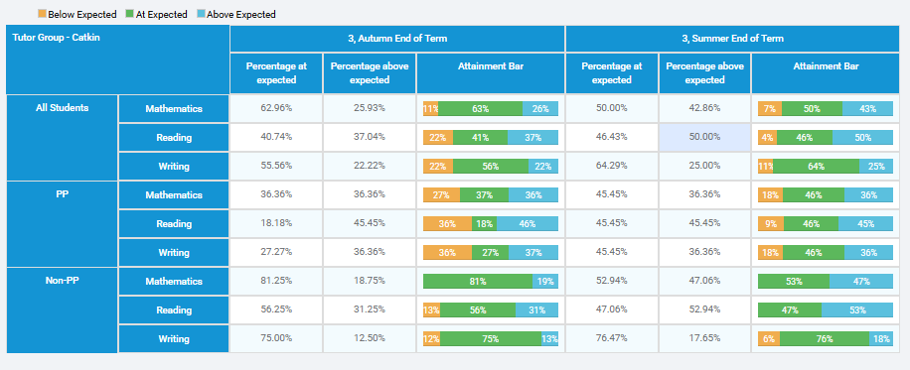

Year 4
Progress: In Year 4, there is no significant difference between the progress measures of PP and their non-PP peers.

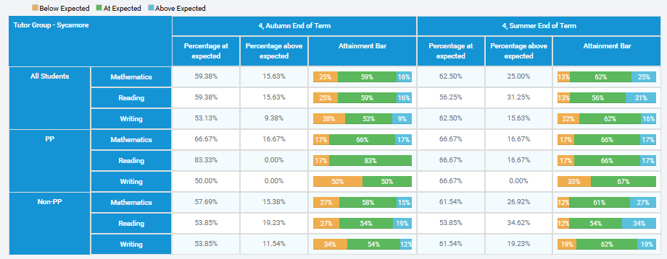

Year 5
Progress: In year 5, PP children’s progress is consistent across all three subjects. They have also made better progress in Maths and Writing compared to their non-PP peers. It is important to note that one new pupil who joined us in the summer term who is working below in all three core subjects, has had an impact on the overall progress measures for this class.
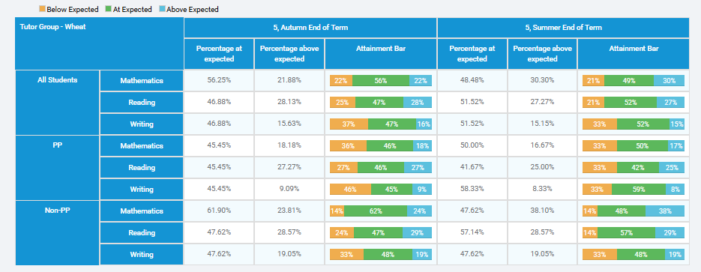

Summary of intended outcomes
Improved attainment in reading, writing and maths for our disadvantaged pupils.
The drive this academic year was to focus on the children who have been making slow progress or consistently working below the expected standard. During target setting and Pupil Progress meetings, their needs have been highlighted and planning adapted to ensure the gap can be closed quicker. 360 monitoring has delved into their individual needs and interventions have been highly focused on supporting these children to close the gap. As a result of this, there has been a significant increase in both progress and attainment in reading and writing at the end of Year 6. While there has been a slight decrease in maths attainment, more children have reached greater depth in comparison to last year, 19% v 7%.

An increased number to meet the Multiplication Timetables Check at the end of Year 4.

Practice this year has been significantly strong in Year 4. Careful monitoring and tracking of times tables has highly focused children on those table facts that they needed to revise. Termly checks have been shared with SLT and children have had the opportunity to practise throughout the year at various points: ass part of morning work, home learning and identified children have had intervention (precision teach) to focus on key tables facts. This has resulted in 5/6 (83%) meeting the check.

An increased uptake and improved attendance in enrichment and extended opportunities amongst our disadvantaged pupils.

We continue to ensure that there are opportunities to enhance the cultural capital of all our PP children across the curriculum. All PP children have attend class trips this academic year. There was an increase parental uptake towards residential trips and all children who wanted to go, were able to attend.

This year, all PP children from Year 1 to Year 6 have had the opportunity to participate in school clubs and tournaments across events from gymnastics to cricket. Several children have represented the school in interschool competitions and fixtures. For the fourth time in a row, we have secured the Gold School Games Mark.

Ten children have participated in this years Rock Steady programme and performed for their parents and the whole school in a variety of ways- with some singing solos and others playing various musical instruments from the drum to the electric guitar.

The Scholar’s Programme was another success this year as 11 children were selected and all graduated successfully.

Inclusion lead to support the well-being of parents and children
Our Inclusion and Well-being lead, Mrs Robertson, continues to support all PP children and work with key families to ensure positive engagement in school. Mrs Robertson has supported various applications towards the Food Bank to homelessness, all with positive outcomes. We continue to have an open-door policy for our parents to seek support and advice.

As a result, our children and their families feel safe and happy to engage with school and have conversations around attendance.

Our disadvantaged attendance figures this year have been consistent with whole school and national: whole school 95.2%, PP 94% and National 94.8%.

Aims for the academic year ahead 2025-2026
- Continue to use key strategies from Writing training to scaffold the writing process across the year.
- To use careful and purposeful adaptations and interventions to support our disadvantaged children in Reading, Writing and Maths.
- To improve arithmetic outcomes in Maths across all classes.

Review of 2023-2024 academic year.
We have analysed the performance of our disadvantaged children using our internal assessments as well as KS2 data during 2023-24.

Christ the Sower School Primary - Statutory Assessments Outcomes 2024
EYFS GLD
All | PP
83% | 71%

Phonics Screening Check
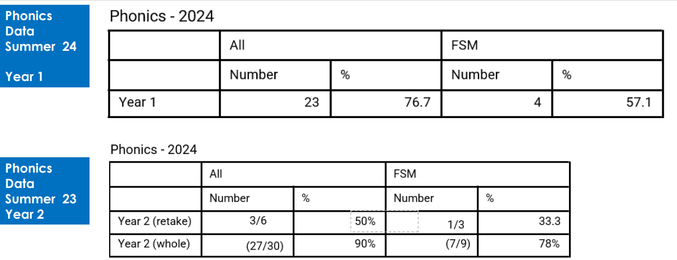

Year 2 additional context – 2 children in Year 2 did not sit the phonics screening check in Year 1 or in the recheck in Year 2. This is due to them having significant needs, global delay and being nonverbal.
End of Key Stage 2 Outcomes
 | Reading |  | Writing* |  | Maths
 | EXS+ | GDS | EXS+ | GDS | EXS+ | GDS
All | 74% | 25% | 86% | 31% | 64% | 15%
PP | 53% | 13% | 67% | 20% | 60% | 7%

*Writing was moderated by the local authority, who were very complementary about the quality of our GDS writing.

Internal Assessments
When tracking internal assessments, there is a focus on the progress of pupils throughout the key points in the academic year. There is a strong emphasis on book scrutiny, pupil voice, as well as teacher administered tests and discussions with teachers during pupil progress meetings to give us a 360 approach to individual children and their progress. We compare and track progress and attainment termly as well as at the beginning of the year and compare this to the end of the year and discuss targeted interventions as necessary.

The table for each year group demonstrates the attainment data in comparison to baseline at the beginning of the year.

Progress: In year 1, in all three core subjects, there has been a reduction in children working below ARE and an increase in pupils working at GDS.
Reading-
There is a 16% reduction in the number of pupils working below ARE in reading, since the autumn term. There is a 14% increase in pupils working above ARE.
Writing –
There is a 15% reduction in the number of pupils working below ARE in writing, since the autumn term.
Maths –
There is a 14% reduction in the number of pupils working below ARE in writing, since the autumn term. There is a 14% increase in pupils working above ARE.
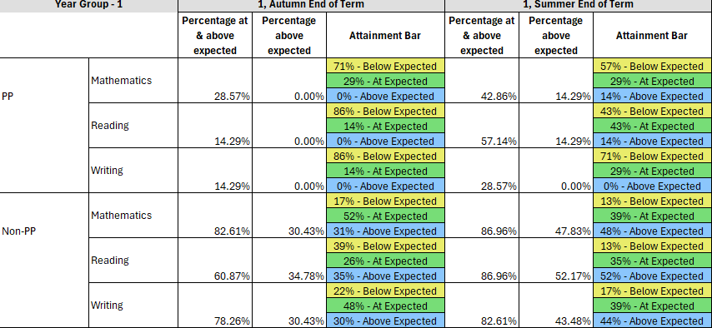

Progress: In year 2, in reading and maths, there has been a reduction in children working below ARE and consistent progress in pupils working at GDS.
Reading –
There is a 10% reduction in the number of pupils working below ARE in reading, since the autumn term.
Writing-
There is consistent progress in the number of pupils working at ARE in writing, since the autumn term.
Maths –
There is an 11% reduction in the number of pupils working below ARE in maths, since the autumn term.


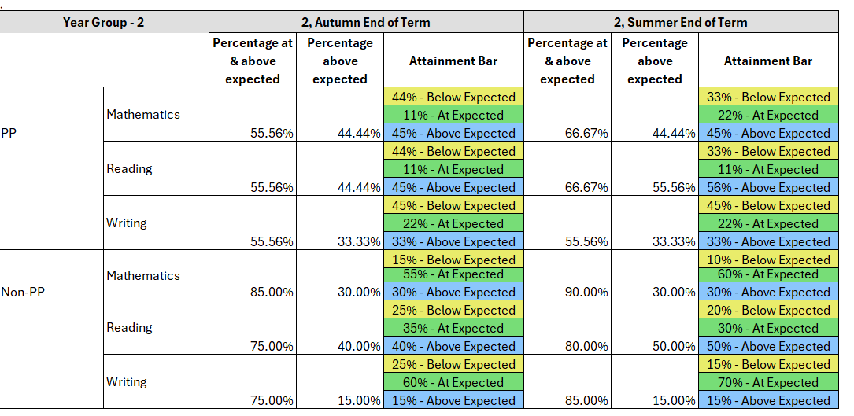

Progress: In year 3, in all three core subjects, there has been a reduction in children working below ARE.
Reading-
There is a 40% reduction in the number of pupils working below ARE in reading, since the autumn term.
Writing –
There is a 20% reduction in the number of pupils working below ARE in writing, since the autumn term.
Maths –
There is a 20% reduction in the number of pupils working below ARE in maths, since the autumn term.

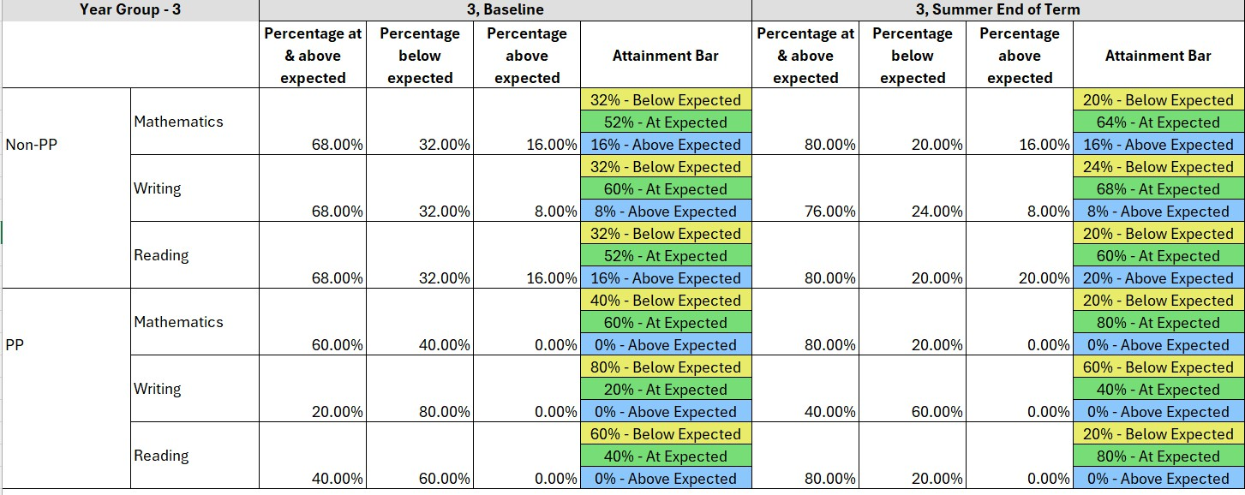

Progress: In Year 4, it is important to note thar out of the 9 PP children, 4 are also on the SEN register, with cognition and learning as their main need.
Reading-
There is a 9% reduction in the number of PP pupils working below ARE in reading, since baseline There is a 10% decrease in pupils working above ARE.

Writing –
There is a 4% reduction in the number of PP pupils working below ARE in writing, since the baseline. There is a 1% increase in pupils working above ARE.

Maths –
There is a 6% increase in the number of PP pupils working below ARE in maths, since baseline. There is a 2% decrease in pupils working above ARE.

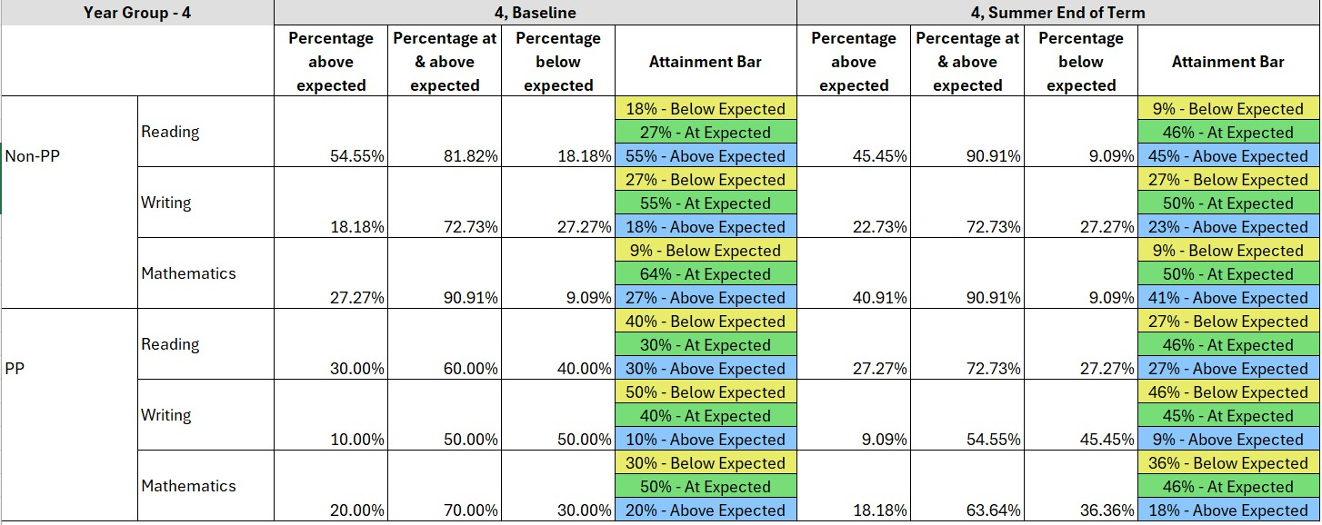

Progress: In year 5, in all three core subjects, there has been a reduction in children working below ARE and an increase in pupils working at GDS.
Reading:
There is a 18% reduction in the number of pupils working below ARE in reading, since baseline. There is a 6% increase in pupils working above ARE.

Writing –
There is a 9% reduction in the number of pupils working below ARE in writing, since the autumn term. There is a 13% increase in pupils working above ARE.

Maths –
There is a 2% reduction in the number of pupils working below ARE in maths, since the autumn term. There is a 18% increase in pupils working above ARE.

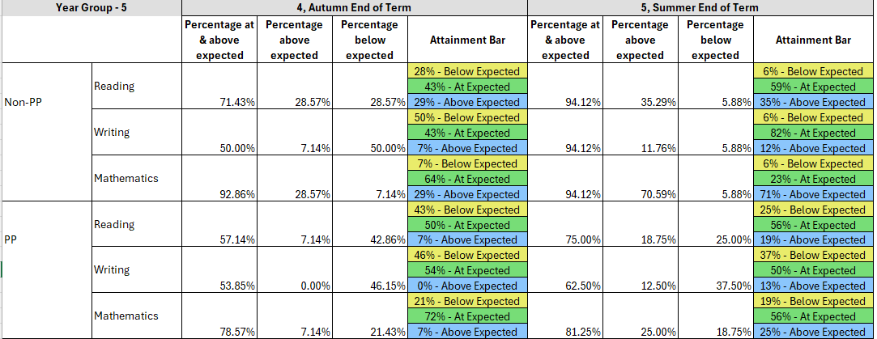

Summary of intended outcomes
Improved attainment in reading, writing and maths for our disadvantaged pupils.
There was a huge focus on targeted interventions for identified children throughout the year. During pupil progress meetings, we were able to identify specific topics and plan for this using in school and after school booster groups, which were taught by teachers. As a result, in writing, 67% of our disadvantaged children performed well, inline with national average of 72%.
The Maths lead used regular CPD, Maths hub resources as well as her guidance to ensure that teachers were able to teach for mastery using the White Rose materials. 60% of our disadvantaged children met the EXS standard in comparison to 64% of the whole cohort.

An increased number to meet the Multiplication Timetables Check at the end of Year 4.

The maths lead introduced timetables booklets, Numbots and rolling numbers to support fluency across all years and abilities. This helped to track and monitor every child and identify specific table interventions. In Y4, 50% of the children met the multiplication check. This was an increase of 16% from the previous academic year.

An increased uptake and improved attendance in enrichment and extended opportunities amongst our disadvantaged pupils.

Our P.E lead and Inclusion Well-being lead worked tirelessly to ensure that all our disadvantaged children are supported with their cultural capital. Over 50 disadvantaged children participated in morning academies, represented the school in various tournaments, festivals and helped the school to secure Bronze for Athletics and Gold in the School Games Award.

Seven children had instrument lessons in school and a further 10 children were chosen for Rock Steady musical band initiative- practising their role in a band to learn how to sing and play an instrument.

All disadvantaged children went on their class trips, and we ensured that all those who wanted to attend their residential trips were able to go. All trips and residentials were subsidised for all children.

Ten of our disadvantaged children took part in the Scholars Programme, which is based on a charity which aims to increase the representation of children from disadvantaged and ethnic minorities backgrounds at the top flight universities, particularly black African and white backgrounds.

Inclusion lead to support the well-being of parents and children
The Inclusion worked tirelessly with our disadvantaged families throughout the year. There was an increased attendance of parents to the ‘Coffee mornings’ where parents were able to seek advice on a range of matters.
Staff reported an increase in parental attendance during parents evening. We were able to catch up with parents separately.

Attendance figures for this year was very positive with our disadvantaged attendance figure of 93% which was broadly in line with National at 94.5%.

Aims for the academic year ahead:
- Improve vocabulary outcome to support reading and writing across the year
- Continue to use CPD to adapt the curriculum for our disadvantaged children
- To use fluency targets and reasoning to improve maths outcome

Externally provided programmes
Please include the names of any non-DfE programmes that you purchased in the previous academic year. This will help the Department for Education identify which ones are popular in England.
Programme | Provider
WRInc | Ruth Miskin Training
Lexia | Rosetta Stone
TT Rockstars | Maths Circle

Further Information (optional)
Use this space to provide any further information about your pupil premium strategy. For example, about your strategy planning, or other activity that you are implementing to support disadvantaged pupils, that is not dependent on pupil premium or recovery premium funding.

