Are you...  …. struggling to pay bills?  …. under pressure from creditors?  …. paying the minimum balance on your credit cards?  …. credit crunched?  People find themselves in debt for all sorts of reasons, often because of circumstances over which they have no control. Maybe it is the loss of a job, a relationship breakdown, or illness has struck out of the blue.  We can help  We offer free confidential money advice to anyone in the Milton Keynes area. Our services are provided by a team of trained volunteers who give advice in accordance with the training provided by Community Money Advice. |  |  |  | Who are we?  MK Money Lifeline is an independent Debt Advice Centre and a member of Community Money Advice.  We are authorised and regulated by the Financial Conduct Authority and many of our advisors have several years experience in debt advising.    What do we offer?  MK Money Lifeline can…  - Listen to you.  - Help you decide which debts to deal with first.  - Suggest ways to avoid getting into more debt.  - Help you with budgeting.  - Contact your creditors to negotiate affordable repayments.  - Refer you to other agencies that may be able to offer you further help. |  |  |  | Is there a fee?  The service we offer is free of charge.    Confidentiality  We take confidentiality very seriously, and conduct interviews in  a discreet environment with private interview rooms available.    Access  We offer wheelchair access and facilities for disabled clients.

Here to help you help yourself…  - Being in debt is very stressful. We provide a listening ear as well as advice.  - We take a friendly and non-judgemental approach, putting people first.  - We value the individual and respect their right and ability to make their own decisions.  - We aim to treat our clients and all other parties fairly and without discrimination.  Authorised and regulated by the Financial Conduct Authority No: 618802  MK Money Lifeline is a registered charity  No: 1146001  MK Money Lifeline  Acorn House  391A, Midsummer Boulevard  Milton Keynes MK9 3HP |  |  |  |   This work has been supported by funding from the  MK Community Foundation who support education and social projects that have a lasting benefit in  Milton Keynes  Also funded and supported by:  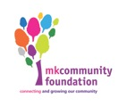  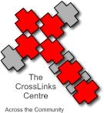  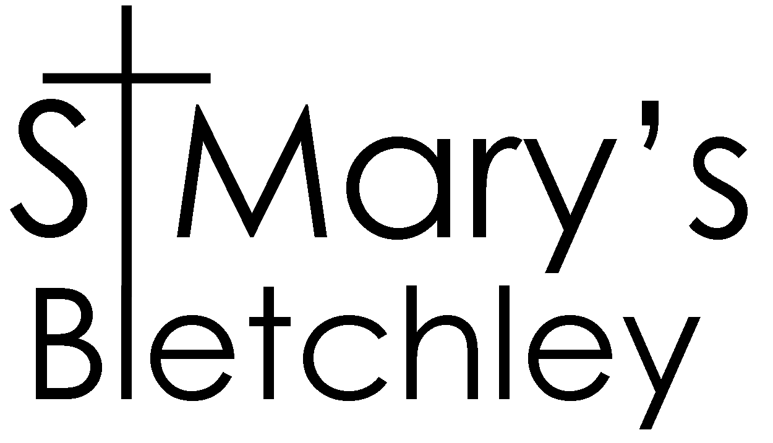    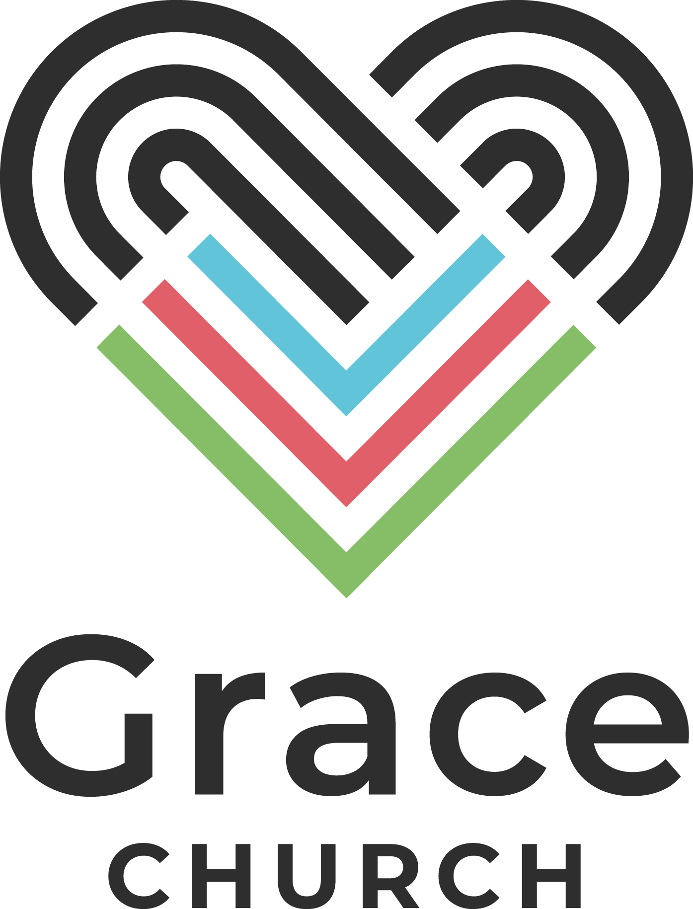 |  |  |  | Free, confidential,  impartial debt advice…    0300 123 5198  01908 550630  office@mkmoneylifeline.org.uk  www.mkmoneylifeline.org.uk

