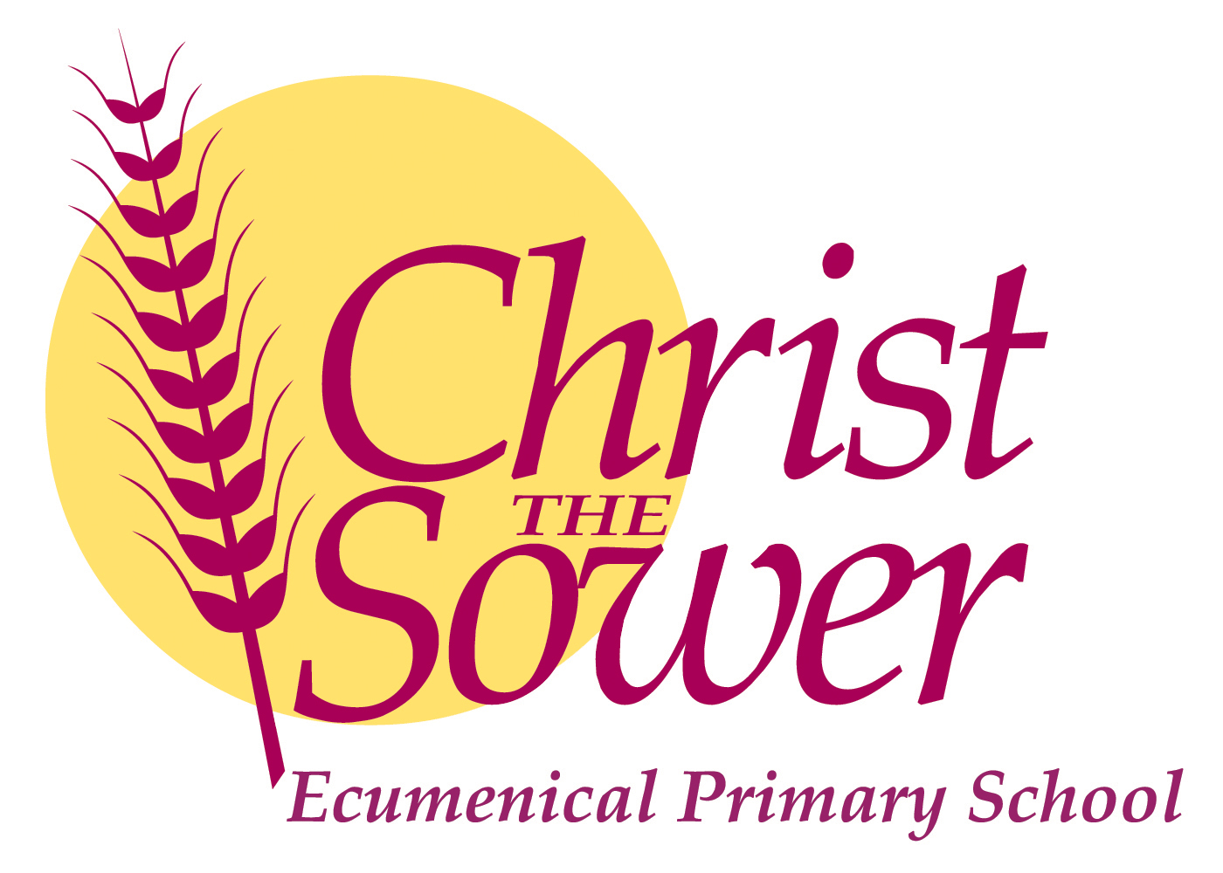

Monday 12th December 2022

Dear Parents and Carers

It is with great regret that I must inform you that Mrs Joseph is leaving us at the end of term, due to personal health circumstances, which mean she is no longer able to commit to a full time position so far from her home.

Therefore, from January 2023, Mustard class will be taught by Mrs Wilson -Andoh, supported by Mrs Mamujee and Mrs Anderson.

This will ensure that there is a strong consistency in the quality of teaching and individual care for the children in Year 3.

As you know, Mrs Wilson-Andoh knows the class well and has been working with Mrs Joseph and Mrs. Martignetti to ensure that there is a strong and comprehensive handover in place before the end of term.

As always, we have your children’s best interests at the heart of every decision made, and this one is no exception to that rule.

If you have any questions, please do not hesitate to contact me.

Kind regards

Mel Nugent

Headteacher

