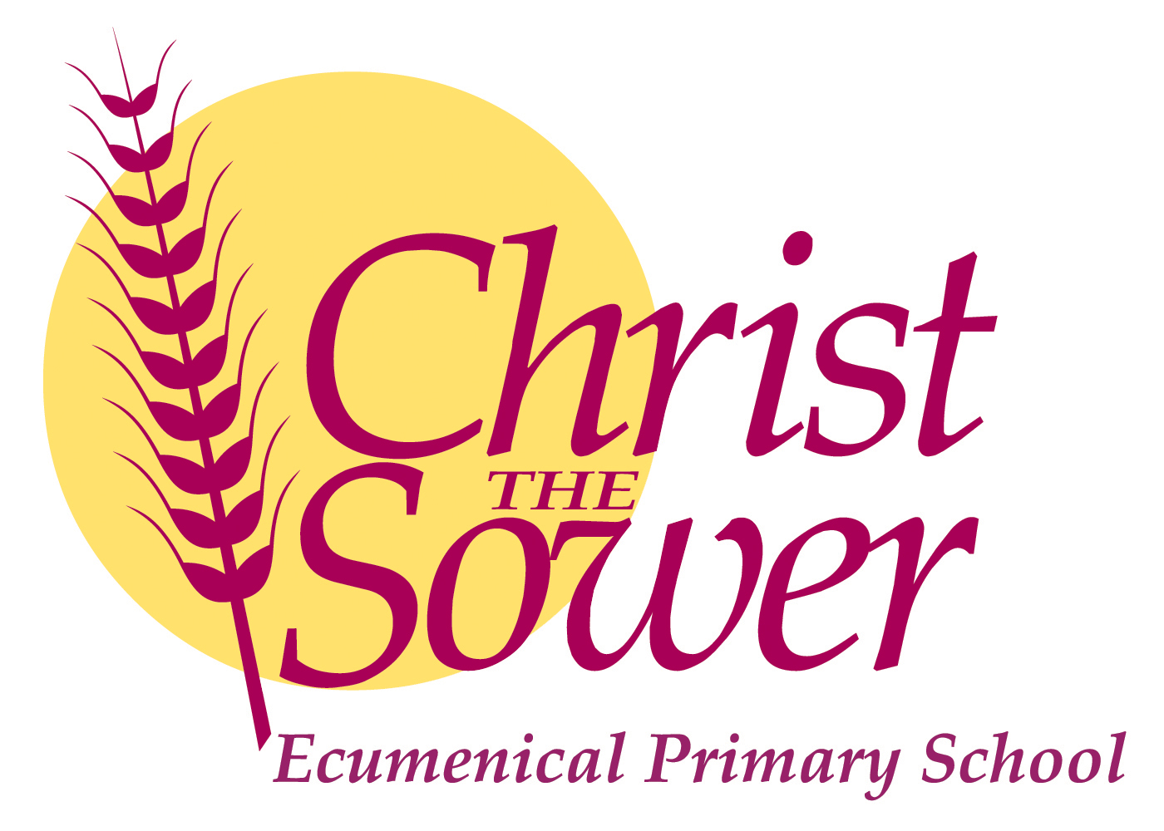

Monday 12th December 2022
The Scholars Programme
Dear Parents

Congratulations to your child for being selected to take part in The Scholars Programme.

The Scholars Programme aims to give children an experience of university learning to help them make an informed decision about their future. Throughout The Scholars Programme your child will take part in small group university-style tutorials delivered by a PhD tutor, teaching a topic based on their current research. Although university may not be for everyone, Miss Christian and Miss. Barr have identified them as having the potential to make a successful application to one of the UK’s most selective universities in the future.

Parent Information and permission form
Please click on the link below to complete an online data collection form as soon as possible and by Monday 19th December 2022.
Link: https://www.tfaforms.com/4905334
For more information on how The Brilliant Club processes the data it collects, please visit: https://thebrilliantclub.org/privacy-policy/

Launch Event
The scholars programme starts with a launch event at a university linked to the area that the pupils will be studying. As we are studying Art History, we have been invited to the Courtauld Institute of Art in London on Thursday 12th January 2023.

Pupils will need to be in school at 7:50am as we need to leave at 8am promptly to ensure that we arrive at the institute for our arrival time of 10am. We will be leaving at 3.30pm so anticipate that we will arrive back at school at around 5.30pm. We will of course keep you up to date via texts and on our school facebook page.
We will be travelling by minibus, and there is no cost to you, as the school will pay for the cost of the minibus.

Lunch will be provided, but please ensure that your child is dressed warmly and has a water bottle. Please let me know of any dietary requirements and provide permission for your child to attend via this link.

Kind regards
Mel Nugent
Headteacher

