Dear parents and carers,
As you will have seen in last week’s newsletter and on our school social media pages, we have recently launched a new home-school reading reward scheme for children in all year groups.
At CtS we recognise the importance and value of reading in driving the future aspirations and successes of our students. Many research studies have clearly indicated that being an engaged reader is one of the greatest predictors of future success. We have developed a new approach to home-school reading which is rooted in our core CtS CARE values.
We ask that all children read their school reading book at home at least five times per week with or without an adult, as appropriate for their age and record this in their reading diary. Each time children read we want them to respond in an age-appropriate way: in EYFS/KS1 we want them to think about CARE and discuss this with an adult (and the adult is to sign the reading record.) As the children move into Year 2/KS2 we would like them to record a written response about what they have read.
All children will now be working towards our new CARE reading awards. The awards have different challenges associated with each aspect of CARE and children must read a new book to complete each one. When children have completed all five stages of their award, they will receive a special badge to wear on their uniform.
We will also hold a weekly book draw where we will select at random one child who is engaging with the challenges to choose a new book to keep. The stages of the awards are:
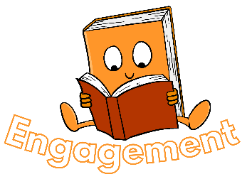 | Engagement is about making time for reading and reading a wide range of texts and genres we want children to:  - make time for reading.  - read different types of texts.  - read different genres.  - read different authors.
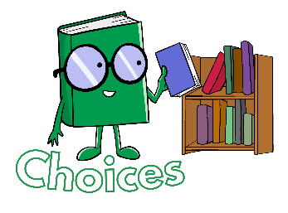 | Choices is about making choices in our reading to help us reach our full potential, this includes thinking about:  - When we read  - How we read  - Where we read  - What we read  - Why we read
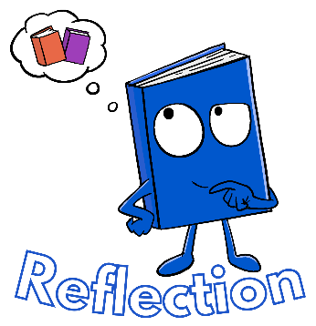 | Reflection is all about thinking more deeply about our reading and sharing it with others, this includes:  - reviewing and recommending books  - sharing books in creative ways with others  - making predictions and inferences about we have read.  - using recommendations to inform the choices we make about reading
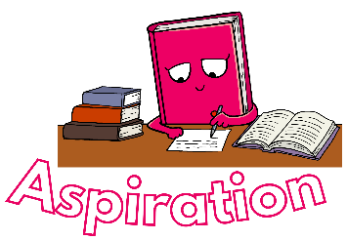 | Aspiration is about challenging ourselves with reading and being driven to read and succeed, this includes:  - being inspired by what we read  - being inspired by authors  - challenging ourselves to read more complex texts from a wider range of genres and authors
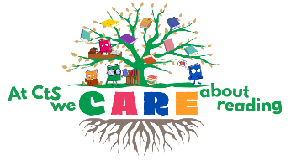 | Reading Awards - The final stage includes our reading award challenges which are all about going over and above to contribute towards our reading culture at CtS. Once these challenges are complete children can receive the following awards:  - EYFS – Bookworm award  - KS1 – Star Reader awards  - KS2 – Reading Champion

In each year group, all children will have now received their new reading diary and will have a school reading book. Hopefully, your child will have talked to you about these new reading awards. In their reading diaries, children have a page of

information about our reading expectations and their first challenge card so they can get started straight away.
Remember, the key message is that children need to be reading a minimum of 5 times a week and we need to see this recorded in their home reading record.
I hope that you have found the information in this letter useful in understanding our approach to home-school reading and our expectations as a school. If you have any questions regarding this, please do speak to your child’s class teacher.

Yours faithfully
Mrs T Palfreyman
English Lead

